**Security Guard**

**Senior Project Presented to the Faculty of Science**

**Department of Computer Sciences**

**Al Maaref University**

**In Partial Fulfillment of the Requirements for the Degree**

**Bachelor of Science**

**Computer Sciences**

**Mostafa Shmaisany - 10120082**

**Fall 2025-2026**

# **Dedication**

﷽

We believe that every beginning has an end, and now our university journey is about to end after all of hard times, working and ups and downs we have faced.

Here we are ending our project with all passion and excitement we have.

First of all, we thank God that without Tawakol on him we would not continue and give all our best, and all the hard work that we went through Allah sees and appreciates it and always send us the best as said in Al-Quran Al-Karim in sorat Al-Najem.40

۞ وَأَنَّ سَعْيَهُ سَوْفَ يُرَى۞

Our appreciation to the martyrs who paid their lives to ensure we live better.

Our appreciation and love to all who were part of this journey especially our family, friends and dearest doctors.

Our appreciation and duas are also sent to those who are sacrificing to let us live in peace, continue our life, and achieve our dreams, to our martyrs that nothing could be done without their sacrifices that we cannot forgot. We dedicate this success to their souls.

My appreciation to my friend **The Martyr & Engineer Sader Diab**, who was part of my capstone journey.

Last but not least, we dedicate also this success to all those who have sought with us to complete this journey.

# **Acknowledgements**

I would like to take this opportunity to express my deepest gratitude and appreciation to all those who have contributed to the completion of this capstone project.

First, we send our love and appreciation to faculty of science at Al-Maaref University for their invaluable guidance, mentorship, and unwavering support throughout this journey. Their expertise, patience, and insightful feedback have been instrumental in shaping the direction of this project and refining its outcomes.

We are also grateful to our supervisor Dr. Moubarak Mohammad for his valuable inputs, encouragement, patient, and continuous support at various stages of this endeavor. Their support and encouragement have been refining our approach and enhancing the quality of this work.  
Furthermore, we extend our appreciation to Dr. Fatima Abdallah, Dr. Rayan El Sibai, and all other doctors who provided assistance, shared ideas, and offered their expertise whenever needed.

We would also like to acknowledge the support and understanding of our family and friends. Their patience, encouragement, and unwavering belief in us have been the driving force behind our dedication to this project.  
Lastly, this project would not have been possible without the collective support, encouragement, and guidance of all those mentioned above. We are truly thankful for their contributions, which have significantly enriched this capstone experience.

# **Table of Contents**

**Dedication** 2

**Acknowledgements** 3

**Table of Contents** 4

**List of Figures** 6

**List of Tables** 8

**List of Abbreviations** 9

**Abstract** 10

**Chapter1: Introduction** 11

**1.1 Overview:** 12

**1.2 Problem Statement:** 12

**1.3** **Proposed Solution:** 13

**1.4 Gantt Chart** 13

**Chapter 2: State of the Art** 17

**2.1 Introduction:** 18

**2.2 Similar Applications:** 18

**2.2.1 BlaBlaCar:** 19

**2.2.2 Commute with Enterprise:** 19

**2.2.3 Gopili:** 20

**2.2.4 Lyft Up:** 20

**2.3 Available Technologies:** 21

**2.3.1 Database Frameworks:** 21

**2.3.2 Backend Frameworks:** 22

**2.3.3 Frontend Frameworks:** 24

**2.4 Conclusion:** 25

**Chapter 3: Requirement Analysis** 26

**3.1 High-level Business Objectives:** 27

**3.2 Functional Requirements Table:** 27

**3.3 Non-Functional Requirements Tables:** 29

**34. Conclusion:** 30

**Chapter 4: Application Modeling and Design** 31

**4.1 Introduction** 32

**4.3 UML Diagrams:** 32

**4.3.1** **Use case Diagram:** 32

**4.3.2 Scenarios:** 34

**4.3.3 Activity Diagrams:** 37

**4.3.4 Relational Schema:** 40

**4.4 Conclusion:** 40

**Chapter 5: Application Implementation** 41

**5.1 Introduction:** 42

**5.2 Used Technologies:** 42

**5.2.1 Used Backend Technologies:** 42

**5.2.2 Used Frontend Technologies:** 42

**5.2.3 Recommender System:** 42

**5.3 Website Screenshots:** 43

**5.4 Code Screenshots:** 75

**5.5 Conclusion:** 80

**Chapter** **6: General Conclusion** 81

**6.1 Recap:** 82

**6.2 Reflections and Challenges:** 82

**6.3 Future work and potential improvements:** 83

**References:** 84

# **List of Figures**

Figure 1 Gant Chart 16

Figure 2 BlaBlaCar 19

Figure 3 Commute with Enterprise 19

Figure 4 Gopili 20

Figure 5 Lyft Up 20

Figure 6 Use Case 32

Figure 7 UseCase-2 33

Figure 8 Post a Ride Activity Diagram 37

Figure 9 Reserve a Ride Activity Diagram 38

Figure 10 Accept/Deny reservation Activity Diagram 39

Figure 11 Relational Schema 40

Figure 12 Home Page 44

Figure 13 Home Page after logging in 45

Figure 14 User's Profile 46

Figure 15 Edit Account Page 46

Figure 16 Post Ride Form 47

Figure 17 Post Ride Form Warning 47

Figure 18 Post Ride-2 48

Figure 19 Post Ride-3 48

Figure 20 Driver History Page 49

Figure 21 Rider's reviews Page 49

Figure 22 Rider's History Page 50

Figure 23 My Rides Page 50

Figure 24 Chat Page 51

Figure 25 Chat Page + Warning 51

Figure 26 Chat Notification 52

Figure 27 Feedback Page 52

Figure 28 Feedback warning 53

Figure 29 Feedback after three warnings 53

Figure 30 Responsive Website 55

Figure 31 About Us Page 56

Figure 32 Services Page 57

Figure 33 Login Page 58

Figure 34 Invalid Login 58

Figure 35 Register Page 59

Figure 36 Register (User Name exists) 59

Figure 37 Register (Email Exits) 60

Figure 38 Password Restrictions 60

Figure 39 Confirmation Password 61

Figure 40 Invalid Email 61

Figure 41 Rides Page 63

Figure 42 View More page 64

Figure 43 View More for fully booked ride 64

Figure 44 Admin Dashboard page 65

Figure 45 Admin Dashboard page-2 65

Figure 46 Users page 66

Figure 47 Roles page 67

Figure 48 Create Role page 67

Figure 49 Rides page 68

Figure 50 Filtering for Pending rides 68

Figure 51 Filtering Accepted Rides 68

Figure 52 Filtering Denied Rides 69

Figure 53 Filtering Expired Rides 69

Figure 54 Reservations page 70

Figure 55 Notification page 71

Figure 56 Accepting Ride 71

Figure 57 Denying Ride 71

Figure 58 Feed Back page 72

Figure 59 Deleting Feed Back 72

Figure 60 Chat Messages page 73

Figure 61 Delete message 73

Figure 62 Deleting unselected message 74

Figure 63 Edit Account page Admin Side 74

Figure 64 Post Ride Code 75

Figure 65 Reserve Ride Code 76

Figure 66 HTML Search code 77

Figure 67 JS Search Code 78

Figure 68 HTML CSS Feedback Code 78

Figure 69 JS Feedback Code 79

Figure 70 Part of Recommender System Code 80

# **List of Tables**

Table 1 Gant Chart 14

Table 2 Similar Applications 21

Table 3 Database Frameworks 22

Table 4 Backend Frameworks 23

Table 5 Frontend Frameworks 25

Table 6 Functional Requirements 27

Table 7 Non-Functional Requirements-Quality 29

Table 8 Non-Functional Requirements-Performance 30

Table 9 Non-Functional Requirements-Constraint 30

Table 10 Scenario1 Post a Ride 34

Table 11 Scenario2 Reserve Ride 35

Table 12 Scenario3 Accept or Deny reservation 36

# **List of Abbreviations**

ASP.Net - Active Server Pages Network Enabled Technologies.

MVC - Model-View-Controller

ML - Machine Learning

HTML - Hypertext Markup Language

CSS - Cascading Style Sheets

UML - Unified Modeling Language

SQL - Structured Query Language

RDBMS - Relational Data Base Management System

PHP - Hypertext Preprocessor

API – Application Programming Interface

DOM – Document Object Model

# **Abstract**

**Security Guard** is a cybersecurity-focused community service website, designed to enhance online safety by detecting phishing attempts and promoting secure communication. It aims to develop an advanced phishing detection platform that enables users to identify and prevent fraudulent activities while also fostering knowledge sharing. The platform integrates modern web technologies and user-centric design principles, offering a secure and user-friendly interface for detecting phishing attempts, sharing security-related articles, and engaging in real-time discussions. The initiative addresses critical cybersecurity challenges, including phishing threats, misinformation, and secure collaboration, ensuring a reliable and safe digital environment through AI-powered phishing detection, text recognition for scanning emails, and real-time group messaging. The website features four roles: Admin, Author, Signed-in User, and Public User. The Admin oversees phishing reports, user activities, and platform management, while Authors can contribute articles and moderate discussions. Public users can access articles, whereas signed-in users can share security insights, participate in group chats, and report phishing attempts. Key features include AI-driven threat detection, user-controlled content sharing, and robust moderation to ensure a safe online experience. An AI component enhances the website’s functionality and security features. This report outlines the project's objectives, design, implementation processes, and anticipated benefits for the cybersecurity community, highlighting its potential for broader adoption and impact.

# **Chapter1: Introduction**

## **1.1 Overview:**

## Cybercrime has been rising globally, with phishing attacks being one of the most prevalent threats. According to a 2023 cybersecurity report, phishing accounts for over 90% of data breaches, making it a major concern for individuals and organizations alike [1]. In Lebanon, the economic crisis has worsened digital security challenges, as financial struggles push more people toward online scams and fraud. Many students and professionals fall victim to phishing due to a lack of awareness and proper security measures. Additionally, with the increasing reliance on digital communication, misinformation and cyber threats are spreading at an alarming rate. Email scams, fraudulent links, and fake websites continue to deceive users, compromising sensitive information. Moreover, as educational expenses rise in Lebanon, students are forced to navigate financial hardships while staying secure online. One of the consequences of this crisis is the increased reliance on online platforms for work and education, making cybersecurity awareness more crucial than ever [2]. Therefore, we are developing an innovative platform that enhances phishing detection while fostering a secure environment for knowledge sharing and real-time discussions. **Security Guard** aims to provide users with AI-powered phishing detection, article sharing for cybersecurity awareness, and secure group messaging, ensuring a safer digital space for students and professionals alike.

## **1.2 Problem Statement:**

Students and professionals face significant challenges in the digital world, including phishing attacks that compromise personal data, difficulty in sharing and accessing reliable articles, and a lack of platforms to connect with experts for guidance. Fragmented tools and misinformation hinder efficient knowledge exchange, while the absence of secure communication channels limits collaborative learning. These issues create barriers to digital security, reliable information sharing, and professional growth, leaving users vulnerable and disconnected in an increasingly online-dependent environment.

## **1.3** **Proposed Solution:**

## To address these challenges, we propose a comprehensive platform that integrates phishing detection, article sharing, and group chat functionalities. The platform will use advanced tools to identify and prevent phishing attempts, provide a structured space for sharing verified articles, and enable group discussions with experts. By combining these features, the solution will enhance digital security, promote reliable knowledge sharing, and foster meaningful connections, creating a safer and more collaborative online community for students and professionals.

## **1.4 Gantt Chart**

​A Gantt chart table is a powerful visual representation of a project's timeline and task schedule condensed into a compact and organized format. It condenses complex project plans into an easily digestible grid, presenting tasks, their durations, and interdependencies in a straightforward manner.

This table shows the several required tasks for our project with their duration in days and dependencies.

Table 1 Gant Chart

|  |  |  |  |
| --- | --- | --- | --- |
| Task No. | Task Description | Task Duration  (days) | Dependencies |
| A | Research | 10 days | None |
| B | Requirement gathering | 10 days | A |
| C | Design models and functions | 7 days | B |
| D | State of Art | 7 days | B |
| E | Database Design | 10 days | C |
| F | Database Implementation | 20 days | E |
| G | Implement front end | 90 days | C |
| H | Implement backend | 100 days | C |
| I | Test | 25 days | G/H |
| J | Report | 40 days | I |

1. Task A: Research for our carpooling website, we need to gather real information related to each feature and service offered within the platform. This task spans 10 days and is not dependent on any other tasks.
2. Task B: Requirements Analysis Task B focuses on analyzing and collecting the requirements for our carpooling website. This stage will last for 10 days and it depends on Task A the Research we had done.
3. Task C: Design models and functions, in this task, we will be designing the functionalities for our carpooling website, including application modeling and design. This task will extend over 7 days and is contingent on the successful completion of Task B (Requirements gathering).
4. Task D: State of Art Task D aims to search for similar websites of our carpooling website. It will take 7 days to complete and relies on the finish of Task B (Requirement gathering).
5. Task E: Database Design This task involves the design of the database schema and structure for our carpooling website. It spans 10 days and is dependent on the completion of Tasks C (Design models and functions)
6. Task F: Database Implementation The primary objective of this Task is to implement the designed database for our carpooling website. It has a 20 days’ timeframe and is contingent on the successful completion of Task E (Database Design).
7. Task G: Front-End Implementation Task, we will implement the front-end and user interface components of the carpooling website. Completion is reliant on the accomplishment of Task C (Design models and functions) and is estimated to take 90 days.
8. Task H: Back-End Implementation, This Task involves implementing the back-end logic and capabilities for the carpooling website, including server-side code development. It enables dynamic functionality and integration with the front-end components. Completion is reliant on the accomplishment of Task C (Design models and functions) and the planned duration is of 100 days.
9. Task I: Testing and quality control for the carpooling website are the main objectives of this Task. It involves evaluating functionality, performance, and reliability using various testing methods, creating and executing test cases, identifying and resolving any bugs or issues, and ensuring the website meets requirements and functions as expected. This task requires 25 days to complete and it depends on the front-end and back-end implementation.
10. Task J: Report Task involves creating a report related to the carpooling website project. The goal is to compile project findings, development process details, and results. This task is estimated to take 40 days, indicating a substantial amount of time and effort needed for gathering data and producing a comprehensive report.

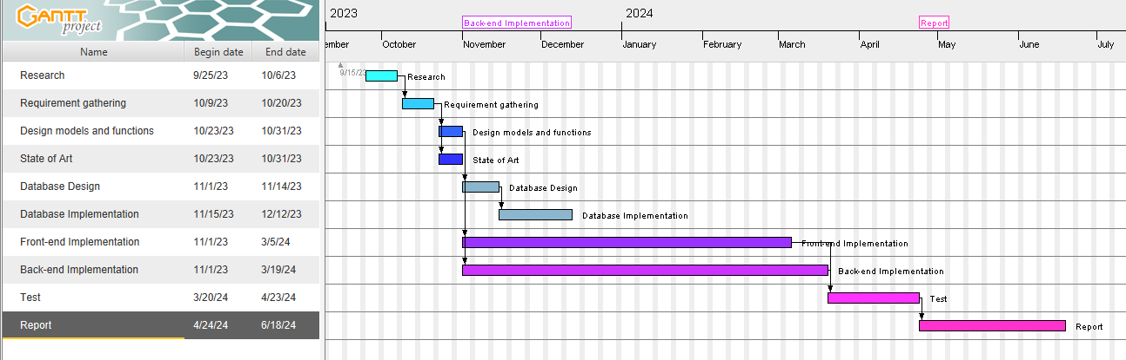

Figure 1 Gant Chart

# **Chapter 2: State of the Art**

## **2.1 Introduction:**

In this section, we delve into the global landscape of carpooling websites, shedding light on similar platforms from various corners of the world. The objective is to explore the diversity and innovation within the carpooling industry, examining how different platforms cater to the unique needs and preferences of users in different regions.

These carpooling websites can serve as a wellspring of inspiration for the development of an innovative carpooling platform that is dedicated to enhancing user experiences and introducing novel features. By closely examining and studying these existing carpooling platforms, we can glean valuable insights and ideas that can inform the creation of a new website designed to not only meet but also exceed consumer expectations. Through the infusion of innovative features and a user-centric approach, we aim to revolutionize the carpooling experience, providing a transportation solution that is not only efficient and eco-conscious but also tailored to the evolving needs and preferences of our users.

## **2.2 Similar Applications:**

Our mission was to delve into these existing carpooling platforms with the aim of extracting valuable insights that can inform our own implementation. By meticulously scrutinizing their strengths and weaknesses, we can uncover opportunities to enhance the user experience and introduce superior features to our own carpooling website.

### **2.2.1 VirusTotal:**

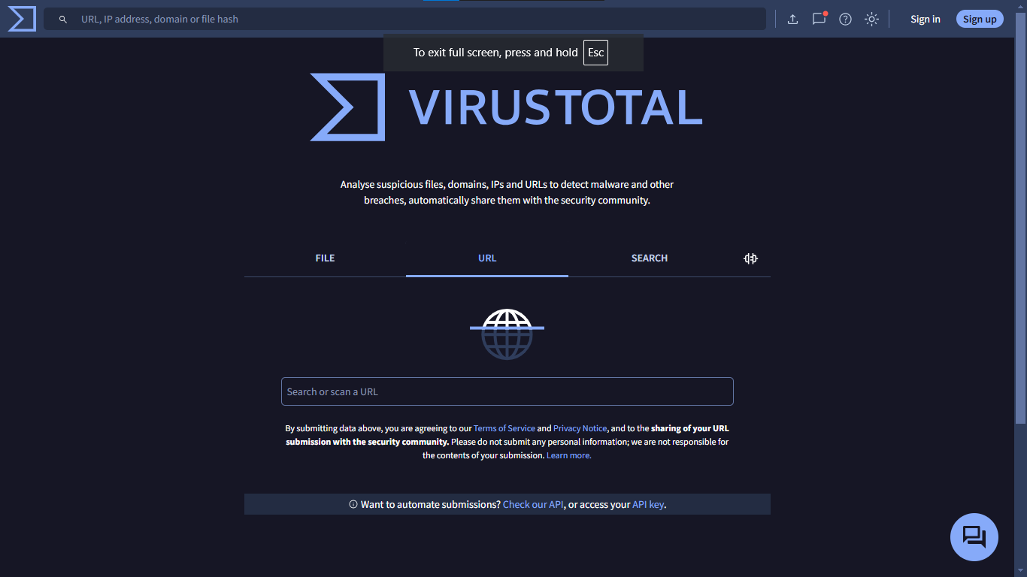

Figure 2 VIRUSTOTAL

BlaBlaCar is a community-based travel app enabling 26 million active members a year to share a ride in 21 countries. Its technology matches drivers with empty seats with passengers heading the same way, so they can share the cost of the trip. With the mission to be the go-to marketplace for shared travel, BlaBlaCar combines carpooling with bus journeys from over 4000 operators to offer a wide choice of affordable and sustainable travel solutions, all in one app. [3]

### **2.2.2 SKYSNAG:**

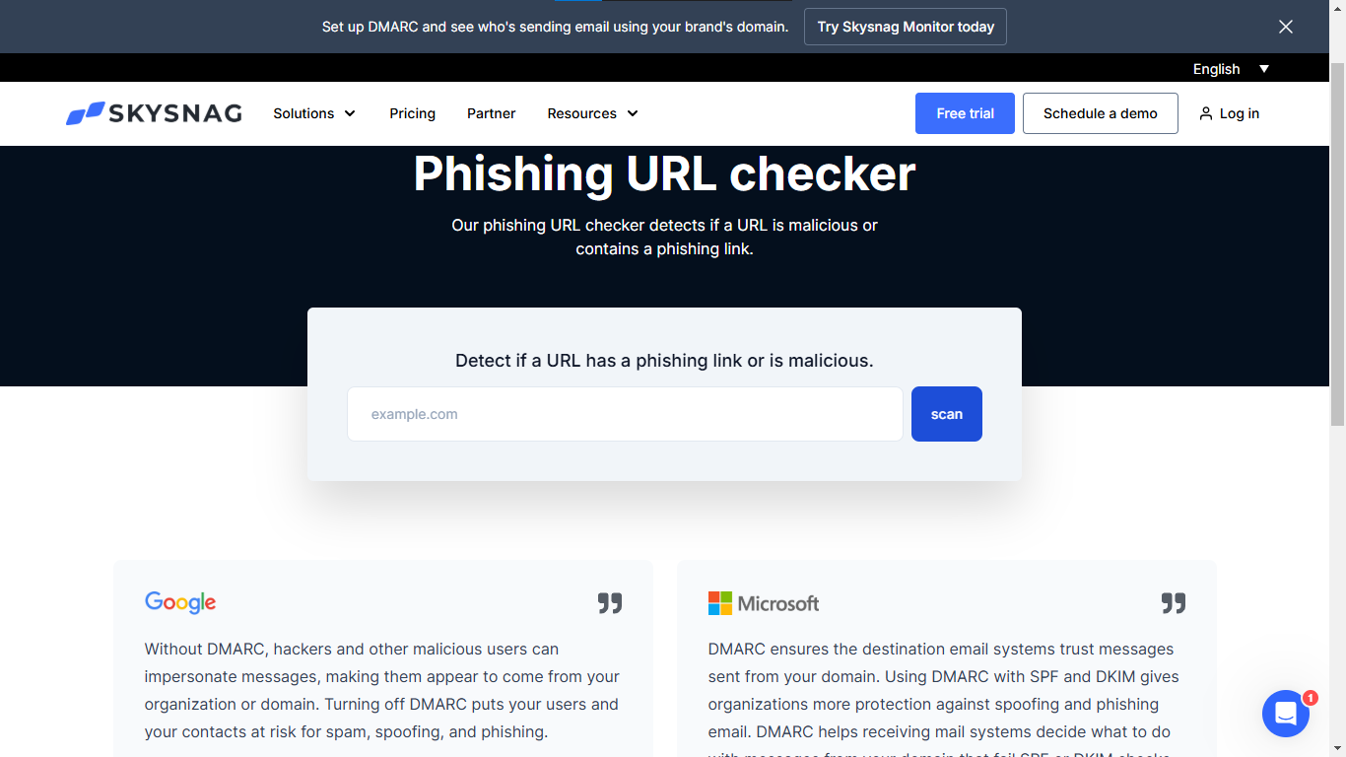

Figure 3 SKYSNAG

Commute with Enterprise is the largest vanpool provider in North America, and vanpooling is the safest mode of public transportation in the U.S. Commute with Enterprise goal is to not only save commuters time and money, but to connect and improve our communities. [4]

### **2.2.3 Kasm Workspaces:**

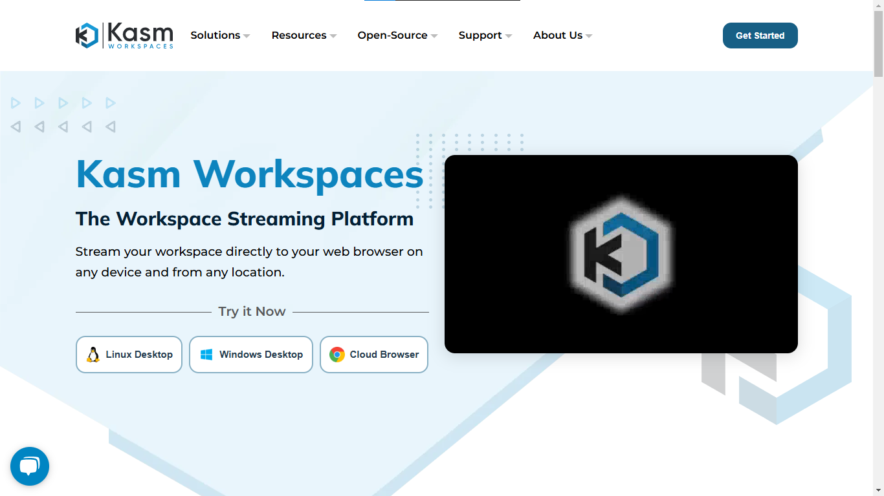

Figure 4 Kasm Workspace

Gopili helps to find the best travel option for your journey by comparing all transportation modes: train, coach, ride share and plane. Once you have chosen the best option, you are redirected to another website for the booking process. [5]

### **2.2.4 CHECKPHISH:**

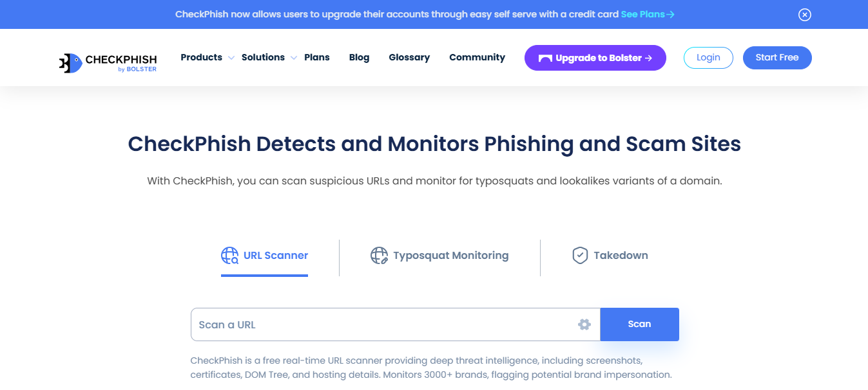

Figure 5 CHECKPHISH

Through Lyft Up initiative, they are working to make sure everyone has access to affordable, reliable transportation to get where they need to go — no matter their age, income, zip, or postal code. [6]

|  |  |  |  |  |  |  |  |  |  |  |  |  |
| --- | --- | --- | --- | --- | --- | --- | --- | --- | --- | --- | --- | --- |
|  | Register | Login  /Logout | URL Analysis | Chat | File Check | Analyze Text & Emails | Talk to Expert | Talk to AI | Scan an Image | Voice to Text | Multiple Detection Models | View Dashboard |
| VirusTotal |  |  |  |  |  |  |  |  |  |  |  |  |
| SKYSNAG |  |  |  |  |  |  |  |  |  |  |  |  |
| Kasm Workspaces |  |  |  |  |  |  |  |  |  |  |  |  |
| CHECKPHISH |  |  |  |  |  |  |  |  |  |  |  |  |
| OUR  “Security Guard” |  |  |  |  |  |  |  |  |  |  |  |  |

Table 2 Similar Applications

## **2.3 Available Technologies :**

This world is in a continuous development. Technologies are available to handle different aspects such as backend, frontend, and database. We must be careful in choosing a suitable technology for creating a professional website that is up to date with future changes. Each project needs its own technology so the choice of technology depends on complexity, requirements and performance of each project.

### **2.3.1 Database Frameworks:**

Database frameworks are tools or sets of libraries that provide developers with an abstraction layer to interact with databases more efficiently. Here are some popular database frameworks:

1. **My SQL:**

A relational database management system based on SQL – Structured Query Language. The application is used for a wide range of purposes, including data warehousing, e-commerce, and logging applications. [7]

1. **Microsoft SQL Server:**

A relational database management system. As a database server that stores and retrieves data as requested by other software applications on the same computer or a remote computer using the client-server model. Microsoft provides APIs to access SQL Server over the internet as a web service. [8]

1. **Oracle DB:**

An Oracle database is a collection of data treated as a unit. The purpose of a database is to store and retrieve related information. A database server is the key to solving the problems of information management. [9]

1. **MongoDB:**

MongoDB is a NoSQL database that stores data in flexible, JSON-like documents, making it ideal for handling unstructured or semi-structured data. It operates on a distributed architecture, enabling high scalability and performance across multiple servers. With APIs and drivers for various programming languages, MongoDB seamlessly integrates with applications, supporting real-time analytics and modern web and mobile services.

|  |  |  |  |  |
| --- | --- | --- | --- | --- |
|  | MySQL | Microsoft SQL Server | Oracle DB | MongoDB |
| Data Model | Relational | Relational | Relational | Document  Oriented |
| Schema | Basic; supports constraints and indexes | Supports constraints, triggers, and indexes | Robust; table spaces, logical storage | Flexible |
| Query Language | SQL (ANSI SQL compliant) | SQL (T-SQL extensions) | Oracle SQL / PL/SQL | MongoDB |
| Data  Relationships | Supports various relationships and foreign key constraints | Enforces referential integrity with constraints | Strong support for enforcing relationships and constraints | Embedding &  Referencing |
| Performance | Good performance, especially for read-heavy operations. | Known for good performance, suitable for various workloads. | High performance and scalability, especially with optimized hardware configurations. | High (optimized for reads/writes at scale) |

Table 3 Database Frameworks

### **2.3.2 Backend Frameworks:**

Backend frameworks are software frameworks designed to aid in the development of the server-side (backend) of a web application. Backend frameworks handle tasks such as database interactions, server-side logic, authentication, and more. Here are some popular backend frameworks:

1. **Flask:**

  A small-scale web framework that was developed using the Python programming language. Flask provides everything necessary to develop web applications without requiring any other particular tools. [10]

1. **ASP.Net Core:**

An open-source web application framework developed by Microsoft. It is a cross-platform framework that enables developers to build high-performance and scalable web applications for multiple platforms. [10]

1. **Laravel:**

A PHP web application framework known for its elegant syntax and features. This technology is widely regarded as one of the top web frameworks and is considered the ideal software for backend development by many experts. [10]

1. Fast API:

Fast API is a modern web framework for building APIs with Python, known for its high performance, ease of use, and automatic interactive documentation. This technology is widely regarded as one of the top choices for developing fast and efficient backend applications, making it an ideal solution for many experts in API development.

Table 4 Backend Frameworks

|  |  |  |  |  |
| --- | --- | --- | --- | --- |
|  | **Laravel** | **ASP.NET** | **Flask** | **Fast API** |
| **Language** | PHP | C# | Python | Python |
| **Framework Type** | Full-featured MVC framework | Framework supporting multiple paradigms | Micro-framework for web development | Asynchronous web framework |
| **Community and support** | Large and active community | Supported by Microsoft, large community | Active community, known for simplicity | Growing, active community |
| **Learning Curve** | Moderate; rich documentation and resources | Moderate to steep depending on modules used | Relatively easy due to simplicity and flexibility | Easy to moderate |
| **Architecture** | Follows MVC architecture | Offers MVC, Web Forms, Web API architectures | Supports various architectural styles | Asynchronous, microservices-friendly |
| **Database Support** | Supports multiple databases | Works well with SQL Server primarily | Supports multiple databases, including ORM support | ORM support (SQLAlchemy, Tortoise-ORM, etc.) |
| **Scalability** | Offers good scalability options | Scalable, especially with Azure integration | Suitable for small to medium-scale applications | High (async & lightweight) |
| **Performance** | Good performance, can be optimized | High performance, especially with optimizations | Lightweight, can be efficient for smaller applications | Excellent |
| **Community Packages** | Rich ecosystem of packages and extensions | NuGet for packages, rich ecosystem | Smaller but growing ecosystem of extensions and packages | Rich ecosystem |
| **Ease of Deployment** | Relatively easy to deploy | Deployment via IIS, Azure, etc. | Lightweight, easier deployment due to simplicity | Simple (Docker, cloud-friendly) |
| **Usage** | Widely used in PHP ecosystem | Popular in enterprise-level applications | Preferred for small to medium-sized projects | API development, ML, microservices |

### **2.3.3 Frontend Frameworks:**

Frontend frameworks are collections of pre-written code and tools that assist developers in building the user interface (UI) and user experience (UX) of a web application. The frontend refers to the part of a software application or a website that users interact with directly. Here are some popular frontend frameworks:

1. **React:**

One of the simplest frameworks to learn. It is an open-source framework; React stands out because of its virtual Document Object Model (DOM). An ideal framework for those who anticipate high traffic and need a stable platform to handle it. [11]

1. **Angular:**

It is the only framework that is based on Typescript. Angular is unique with its two-way data binding feature. It means there is a real-time synchronization between the model and the view, where any change in the model reflects instantly on the view and vice versa. [11]

1. **Vue.js**:

It is a simple straightforward framework. Vue is versatile, and it helps you with multiple tasks. From building web applications and mobile apps to progressive web applications, it can handle both simple and dynamic processes with ease. [11]

1. Blazor:

Blazor is a simple and powerful framework. It is versatile and enables you to build interactive web applications using C# and .NET. From developing single-page applications to full-stack web apps, Blazor seamlessly handles both simple and complex processes with ease.

Table Frontend Frameworks

|  |  |  |  |  |
| --- | --- | --- | --- | --- |
|  | Angular | React | Vue.js | Blazor |
| Type | Full-fledged MVC framework | Library for building user interfaces | Progressive JavaScript framework/library | Component-based .NET web framework |
| Language | Typescript | JavaScript | JavaScript | C# |
| DOM | Regular DOM manipulation | Virtual DOM | Virtual DOM | Virtual DOM (Blazor WebAssembly), Server-side rendering (Blazor Server) |
| Learning Curve | Steeper due to its comprehensive nature | Moderate, easier for JavaScript developers | Gentle and easy to pick up | Moderate (easy for .NET developers) |
| State Management | Built-in, uses RxJS and NgRx | Requires external libraries (e.g., Redux) | Vuex for centralized state management | Built-in, uses cascading parameters, context, and third-party libraries |
| Directives | Rich set of built-in directives | Fewer built-in directives | Templates and directives similar to Angular | Razor directives |
| Community | Supported by Google | Maintained by Facebook | Developed and maintained by community | Growing, supported by Microsoft |
| Performance | Generally good, but heavier DOM operations | Efficient due to virtual DOM | Lightweight and efficient | Good (depends on hosting model) |
| Popularity | Widely used in enterprise applications | Widely adopted in the industry | Growing popularity, gaining traction | Increasing, especially among .NET developers |

## **2.4 Conclusion:**

In this chapter, we explore similar security management applications and review the most popular web development technologies useful for building our project. We choose from the above technologies Microsoft SQL Server and MongoDB as databases, ASP.NET Core (MVC & API) as the backend framework, and FastAPI for handling AI-related tasks. For the frontend, we use Razor views within the ASP.NET Core framework, alongside HTML, CSS, Bootstrap, and JavaScript. Now, we are ready to build our **Security Guard** application by leveraging the efficiency of these technologies.

# **Chapter 3: Requirement Analysis**

## **3.1 High-level Business Objectives:**

The overarching business objectives of this project are providing an easy and reliable transportation solution for university students, particularly those who live far from the campus. In addition, decrease the number of cars on campus to alleviate parking space shortages and reduce traffic congestion. Moreover, we are aiming to ensure students can benefit from low-cost rides, especially those facing financial difficulties, making transportation affordable and accessible for all.

## **3.2 Functional Requirements Table:**

Table (6) shows the functional requirements of our project.

Table 6 Functional Requirements

|  |
| --- |
| **Functional Requirements** |
| 1. Public user shall be able to create an account. |
| 1. Public user shall be able to log in. |
| 1. Public user shall be able to scan text. |
| 1. Public user shall be able to scan link. |
| 1. Signed in User shall be able to view dashboard. |
| 1. Signed in User shall be able to edit his account. |
| 1. Public user shall be able to download APKs. |
| 1. Public user shall be able to view articles. |
| 1. Public user shall be able to view a specific article. |
| 1. Public user shall be able to change between dark and light modes. |
| 1. Signed in User shall be able to do everything the (general) user can do. |
| 1. Signed in User shall be able to filter scans (safe, dangerous, ambiguous) |
| 1. Signed in User shall be able to filter scan types (link or text(email)) |
| 1. Signed in User shall be able to change password. |
| 1. Author shall be able to do what the Signed in User can do |
| 1. Author shall be able to view his/her articles |
| 1. Author shall be able to post an article |
| 1. Author shall be able to edit her/her articles. |
| 1. Author shall be able to delete his articles. |
| 1. Signed in User shall be able to comment on articles. |
| 1. Admin shall be able to do what the author can do |
| 1. Admin shall be able to view scans count |
| 1. Admin shall be able to register a User |
| 1. Admin shall be able to delete a User |
| 1. Admin shall be able to assign roles to users |
| 1. Admin shall be able to verify users. |
| 1. Admin shall be able to create roles. |
| 1. Admin shall be able to delete roles. |
| 1. Admin shall be able to delete roles for specific User. |
| 1. Public user shall be able to register. |
| 1. Public user shall be able to login/logout. |
| 1. Public user shall be able to modify theme mode on mobile |
| 1. Public user shall be able to modify theme color on mobile |
| 1. Public user shall be able to share feedback on mobile |
| 1. Public user shall be able to scan link on mobile |
| 1. Public user shall be able to scan text on mobile |
| 1. Signed in User shall be able to send a message |
| 1. Signed in User shall be able to delete a message |
| 1. Signed in User shall be able to modify a message |
| 1. Signed in User shall be able to ask AI Large Language Model |
| 1. Signed in User shall be able to convert voice to text. |
| 1. Signed in User shall be able to upload image to recognize text from it |
| 1. Signed in User shall be able to capture image to recognize text from it |
| 1. Signed in User shall be able to view scan results of different models. |
| 1. Admin shall be able to view scans of all users |
| 1. Admin shall be able to export scans as a data file (like Excell). |

## **3.3 Non-Functional Requirements Tables:**

The bellow tables show the three types (quality, performance, and constraints) of non-functional requirements of our project.

* **Quality:**

Table 7 Non-Functional Requirements-Quality

|  |  |
| --- | --- |
| **Non-Functional Requirements** | **Quality** |
| 1. The admin shall log in to enter information. | Security |
| 1. User shall have an account to comment on an article. | Security |
| 1. The password of the account shall be of six characters containing at least one upper case, one lower case, one digit, and one special character. | Security |
| 1. User shall have Author role to be able to post articles. | Security |
| 1. User shall have an account to be able to post a ride. | Security |
| 1. The website shall be able to open continuously without crashing. | Reliability |
| 1. As the load on the system increase the throughout shall remain constant. | Scalability |
| 1. The website shall be available all days of the week. | Availability |
| 1. The website shall be responsive to the screen size of computers and phones. | Portability |
| 1. All the people from different ages shall be able to use the application. | Usability |
| 1. The website shall be able to run on Windows 10 and Windows 11 | Interoperability |
| 1. The application shall be available for android and windows and web | Interoperability |

* **Performance:**

Table 8 Non-Functional Requirements-Performance

|  |  |
| --- | --- |
| **Non-Functional Requirements** | **Type** |
| The system shall move from page to another within 3 sec. | Performance |
| The message in chat box shall be sent within 2 sec | Performance |

* **Constraints:**

Table 9 Non-Functional Requirements-Constraint

|  |  |
| --- | --- |
| **Non-Functional Requirements** | **Type** |
| 1. The front end of the website shall be implemented in HTML-5 language. | Constraint |
| 1. The back end of the system shall be done by ASP.NET Core framework. | Constraint |
| 1. The system shall be done by mvc to develop Web Applications. | Constraint |
| 1. The interface shall be designed using CSS and Bootstrap. | Constraint |
| 1. The system shall use SQL Server as a database | Constraint |
| 1. The system shall use MongoDB as a database for messaging | Constraint |

## **34. Conclusion:**

In conclusion, the requirements outlined in this section are the foundation upon which our Security Guard website will be built. They are carefully designed to align with our high-level business objectives of providing a seamless, sustainable, and user-centric transportation solution. As we move forward with the implementation phase, these requirements will serve as our guiding principles to deliver an innovative and effective carpooling experience.

# **Chapter 4: Application Modeling and Design**

## **4.1 Introduction**

In the context of our share a ride project report. In this section, we will go through several types of diagrams that elaborates our website’s functions gradually.

## **4.3 UML Diagrams:**

### **Use case Diagram:**

The figure below shows our use-case without authentication for simplicity note that some functions need authentication. Our use case contains five actors, which are public user that serves as a viewer, User, Admin, Transportation Manager and Content Manager where all their functionalities are listed below in the figure.

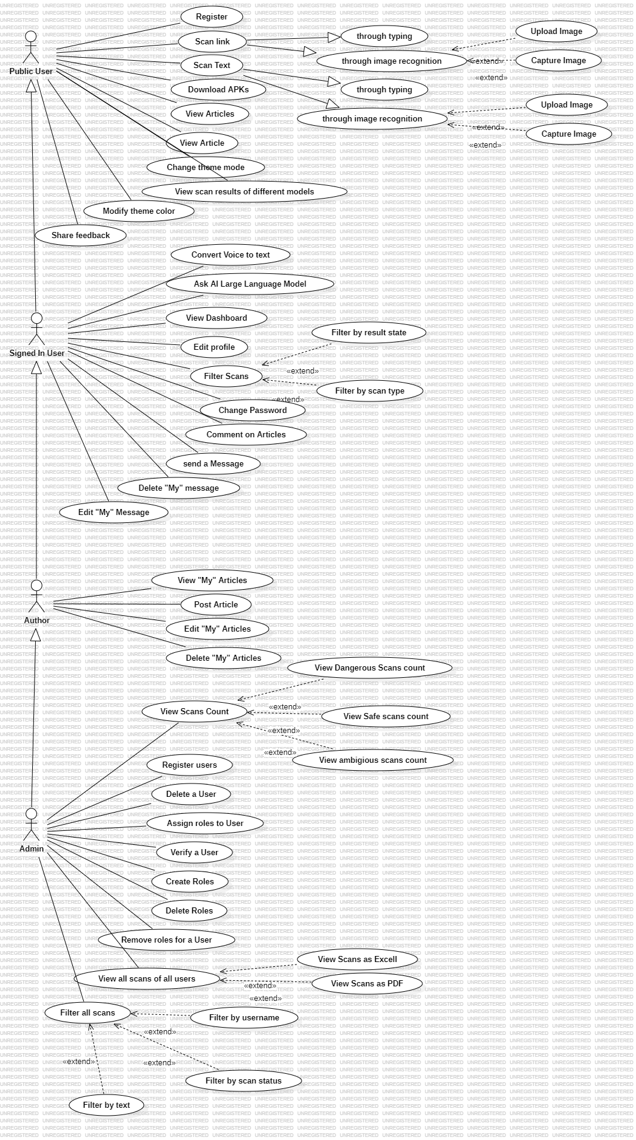

Figure Use Case



Figure UseCase-2

### **4.3.2 Scenarios:**

The tables that are presented below are some sample scenarios for our project: Post a ride, Reserve a ride and Accept or deny reservation.

Table 10 Scenario1 Post an article

|  |  |
| --- | --- |
| **Scenario Name** | Post an article |
| **Participating Actors** | Author |
| **Description** | Allow the user to post an article |
| **Entry Conditions** | The user should be logged in. |
| **The Flow of Events** | * Author login the page * Author presses on articles * Author presses on post an article * Author fills the form * Author submits the form |
| **Exit Conditions** | The new article will be added to articles. |
| **Exceptions** | * User enters a wrong email or password so login will not be completed. * User misses some important information about the article so submission will not be completed |

Table 11 Scenario2 Scan a link on mobile app through image

|  |  |
| --- | --- |
| **Scenario Name** | Scan a link on mobile app through image |
| **Participating Actors** | User |
| **Description** | It allows the user to scan a link |
| **Entry Conditions** | No prerequisites. |
| **The Flow of Events** | * User navigate to the scanner page * User upload or capture image * User clicks on scan button * User click on analyze link * User receives the scan result |
| **Exit Conditions** | The link is now classified as safe, danger, or ambiguous |
| **Exceptions** | * User doesn’t have a link in the image, will not receive the analyze button |

Table 12 Scenario3 Scan a link on website

|  |  |
| --- | --- |
| **Scenario Name** | Scan a Link on Website |
| **Participating Actors** | User |
| **Description** | It shows how user can scan a link safety |
| **Entry Conditions** | No prerequisites |
| **The Flow of Events** | * User navigate to scan page * User selects link tab * User type the link * User view the result |
| **Exit Conditions** | The link is now classified as safe, danger, or ambiguous |
| **Exceptions** | * User enters invalid link format, will not be accepted. |

### **4.3.3 Activity Diagrams:**

The below figures shows the activity diagrams of our website that are Post a ride, Reserve a ride and Accept/Deny ride.

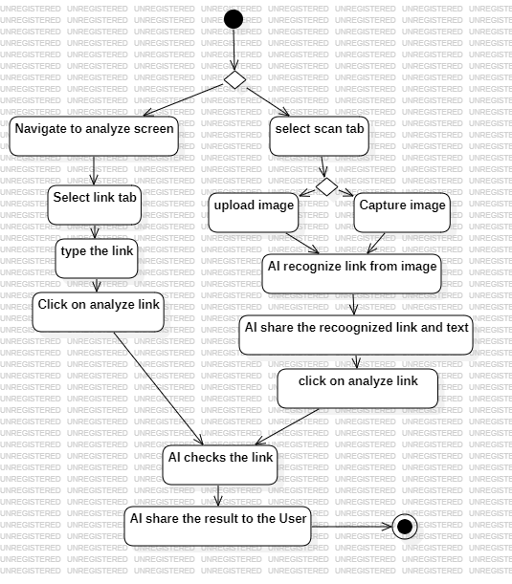

Figure 8 Post a Ride Activity Diagram

Figure 8 shows that to press on post a ride button you first need to be logged in, then you must fill the information of your ride that are mentioned above after that press save button and wait the response from the transportation manager.

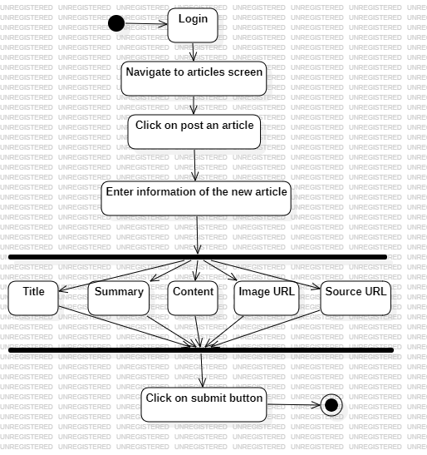

Figure 9 Reserve a Ride Activity Diagram

Figure 9 shows how to reserve a ride. You should first go to Rides page that gives you that list of rides. After that press on view more, to see more details about the ride you choose. Now the reserve button will appear to you, if you are logged in, you will be able to reserve the ride and wait for the driver’s response, and if you are not logged in, you will be taken to log in page to log in.

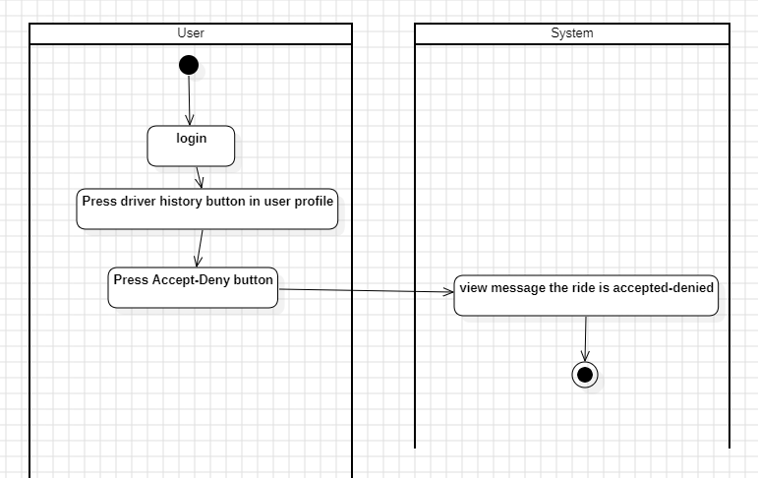

Figure 10 Accept/Deny reservation Activity Diagram

Figure 10 shows that to accept or deny a reservation, you should first be logged in. Then enter your profile and press on Driver History where all reservations on your ride will appear. After that you can press on accept or deny button then a message will appear to assure that the reservation is accepted or denied successfully.

### **4.3.4 Relational Schema:**

The relational schema is represented in Figure 11 that illustrates the relations with nine tables that are Ride, Reserve, User, Website Feedback, Review Riders, Chat, Rate, Location and Writing Feedback. It also shows the primary keys, foreign keys and optional attributed that are present.

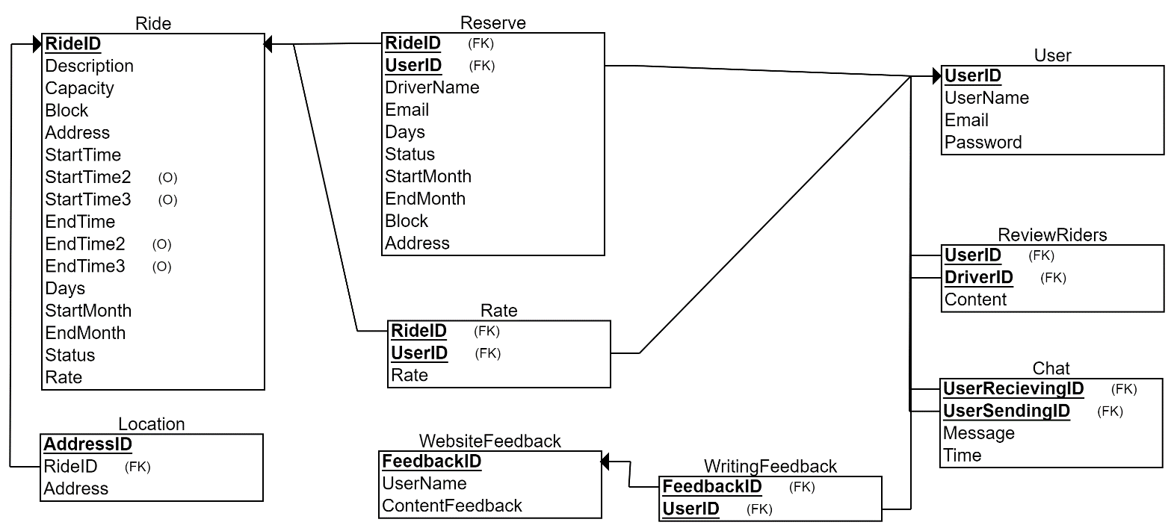

Figure 11 Relational Schema

## **4.4 Conclusion:**

In conclusion, various techniques are employed in the development and management of websites, including use case diagrams, activity diagrams, and relational schemas. Use case diagrams, which illustrate system functionality and user requirements, guide the design process. Activity diagrams depict workflows, simplifying website operations. Relational schemas define the structure and organization of the website's database, ensuring data integrity and efficient storage and retrieval. Collectively, these tools provide a comprehensive approach to website creation, promoting effective project management, client satisfaction, and a functional system.

# **Chapter 5: Application Implementation**

## **5.1 Introduction:**

In this chapter, we will go through our implementation journey that leads to this useful software. We will provide you with technologies we had used with detailed process. In addition, we will add some screenshots of our website that will let you be on track of what we did. These images will illustrate the result of what we had done using these technologies.

## **5.2 Used Technologies:**

There are several technologies that are available, but we aim to use the technologies that made our website more friendly and easy to use. We will provide you with the technologies we use that leads to this successful smooth website with perfect functionalities.

### **5.2.1 Used Backend Technologies:**

For frameworks, we used .net using C# language for the backend of our website. In addition, for database implementation we had used Microsoft SQL Server that is relational database management system that supports wide variety of transaction processing. In addition, for phishing detection part we had used Machine Learning (ML), and FastAPI for its API sharing. Also, we have used MongoDB for messaging.

### **5.2.2 Used Frontend Technologies:**

Here we come to the part of creativity. To ensure that we will have a well-organized and attractive client-side view, our front end was depending on CSS, HTML, Bootstrap and Java Script. With the use of these technologies, we were able to perform a friendly visual presentation that contains interactive features. The web page’s markup and structure are provided by HTML. CSS and Bootstrap manage the website's layout, colors, font, and overall visual appeal. It also handles styling and presentation. With the addition of interactivity and dynamic behavior, JavaScript makes it possible for functions like form validation, processing user input, animations, and real-time updates. A good front-end website leads for user satisfaction so this part is so essential to attract more users and let the website more interactive. Also we have used Flutter for the mobile and cross-platform applications.

### **5.2.3 Phishing Detection:**

To perform phishing detection, we have searched for a dataset of phishing links, codes, emails, and texts. Then we trained a Logistic Regression model on that data, which got an accuracy of 0.87.

### **5.2.4 Deployment:**

For deployment, we used Docker to containerize the apps, and GitHub CI/CD pipelines, so the changes will be built and deployed automatically whenever we push to GitHub. The .Net apps has been deployed to azure which works smoothly together. And for the AI model and FastAPI app we deployed it to AWS.

## **5.3 Website Screenshots:**

The following figures are screenshots of our dynamic website that will show you several pages and how they appear. The screenshots serve as the visual appearance of the website and gives overview for the while website. Every figure represents a particular page, highlighting its unique layout, content organization, and interactive features.

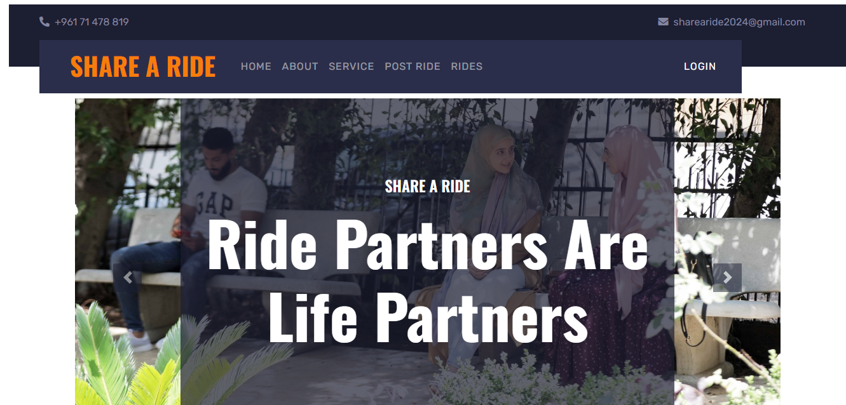

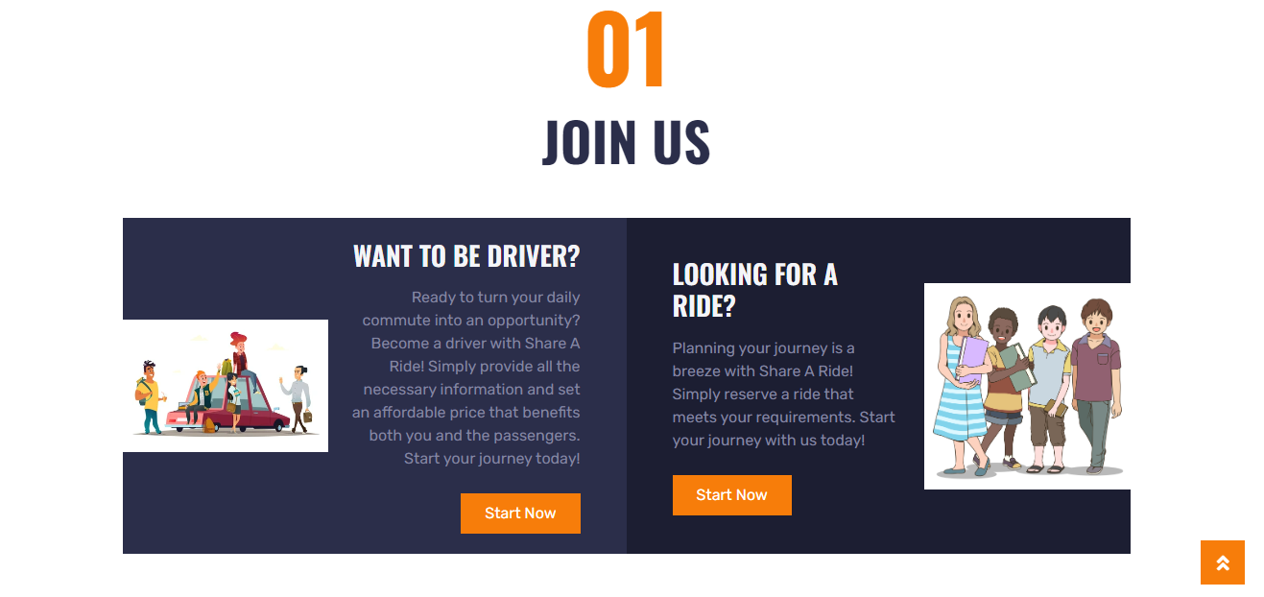

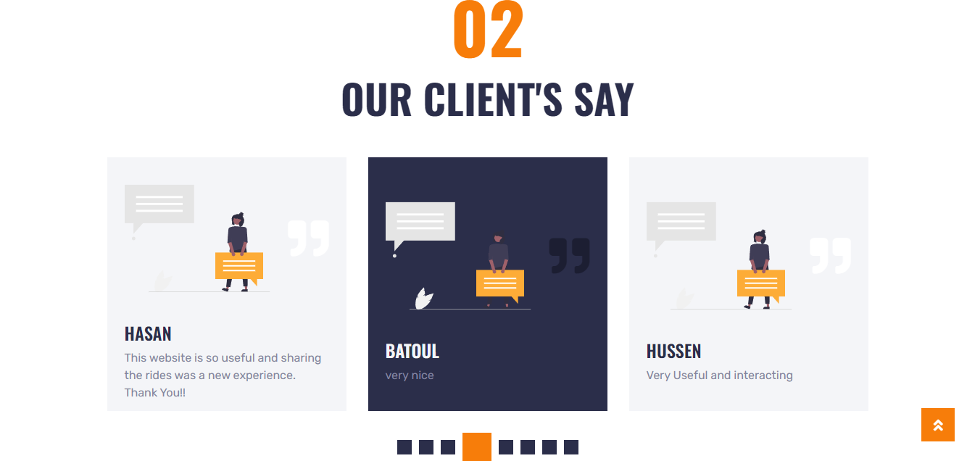

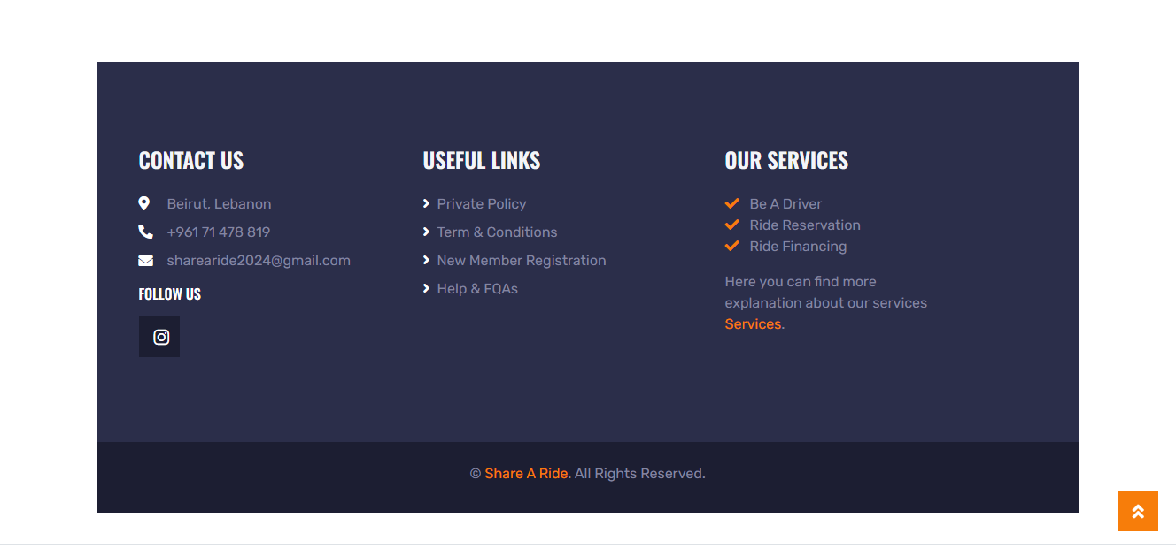Figure 12 Home Page

This is our website’s home page. At the top we have a navigation bar that includes going through about us ad services pages also it have the post a ride, rides and login functions. The join us part allow the user to choose if he want to post a ride and be a driver or he is searching for a ride to reserve and be the rider. When clicking on Be a Driver part the post a ride form will appear for you, while when clicking on Looking for a ride the rides page will be opened for you to see the list of available rides and reserve the suitable for you, note that user should be logged in in order to enter post a ride page. We have also in the home page part that is called “Our clients’ say” this part includes the feedbacks of the users about the website and everyone can see those feedbacks for credibility. Ending the home page with a footer that contains contact us part, useful links that help the user and summary about the services of our website. In addition, to make your navigation easy in the home page we have an arrow on the right that allow the user to return to the top of the page when he wants.



Figure 13 Home Page after logging in

This is the home page after logging in where a feedback and chat appears for the user and a profile icon to see everything related to him.

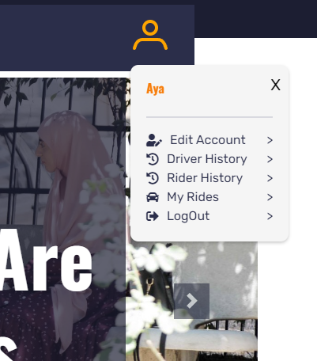This figure shows that the user is able to edit his account, view who reserved his ride if he has in driver history, view the rides he reserved in rider history, and view the rides he posted in My Rides, and logout from his account.

Figure 14 User's Profile

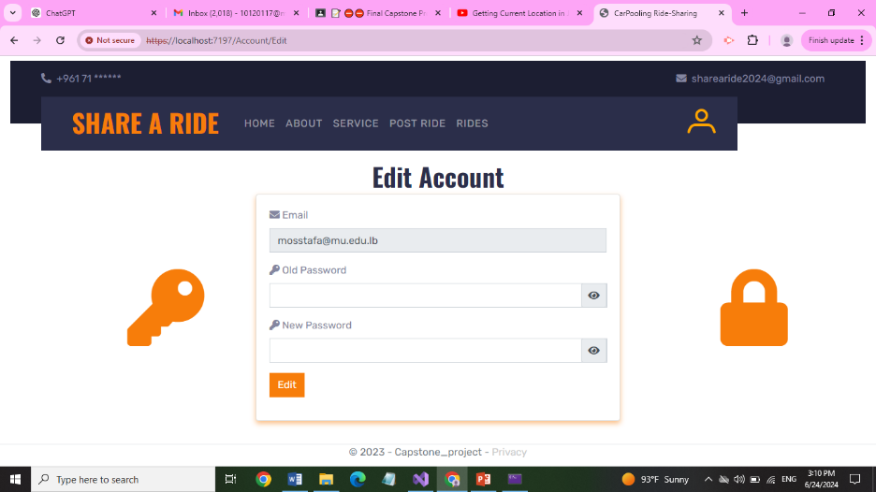

Figure 15 Edit Account Page

Figure 15 shows us that the user is able to edit his password.

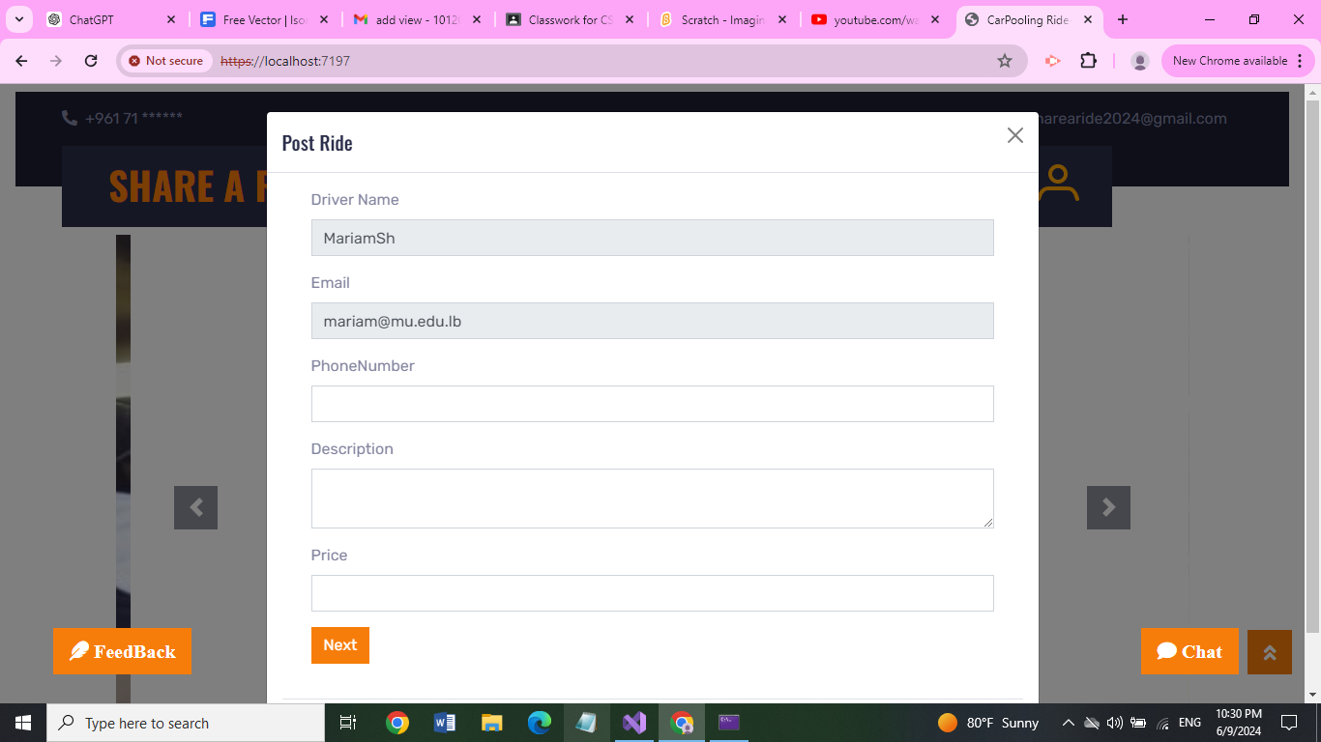 Figure 16 Post Ride Form

This figure shows our post ride form that you should fill if you have a ride that you want to share with us.

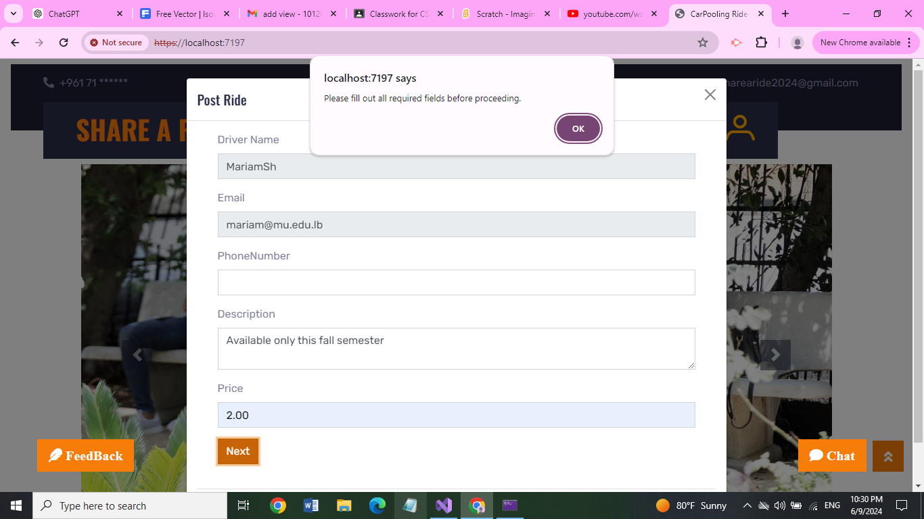

Figure 17 Post Ride Form Warning

As shown in this figure you cannot continue filling the form if the previous pages are not completed.

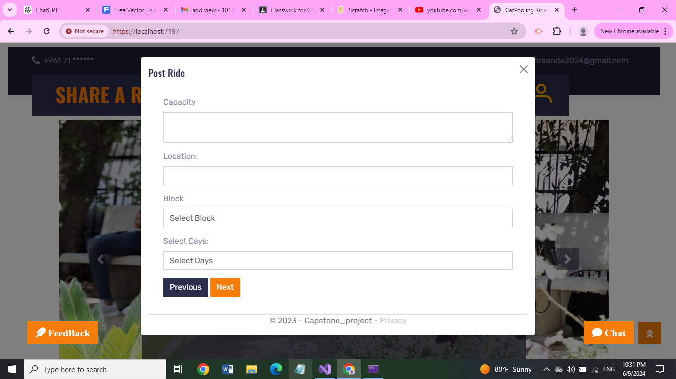 Figure 18 Post Ride-2

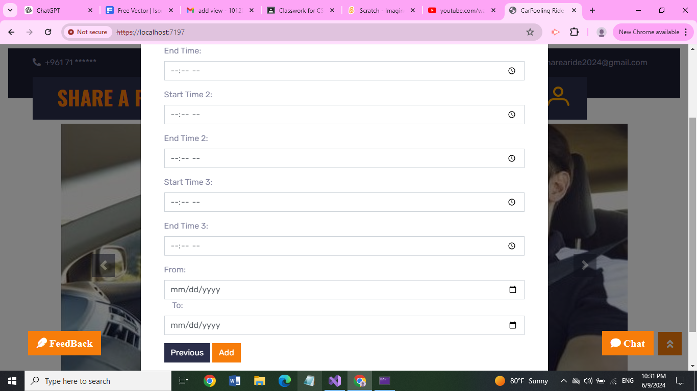 Figure 19 Post Ride-3

Figures 18 and 19 show the other fields of the Post Ride form that also should be filled.

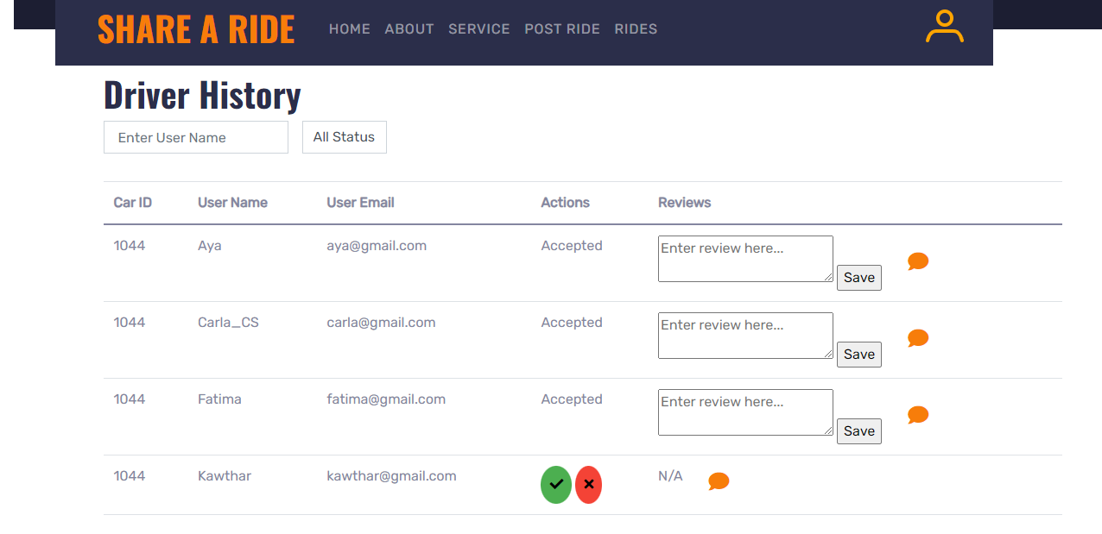Figure 20 Driver History Page

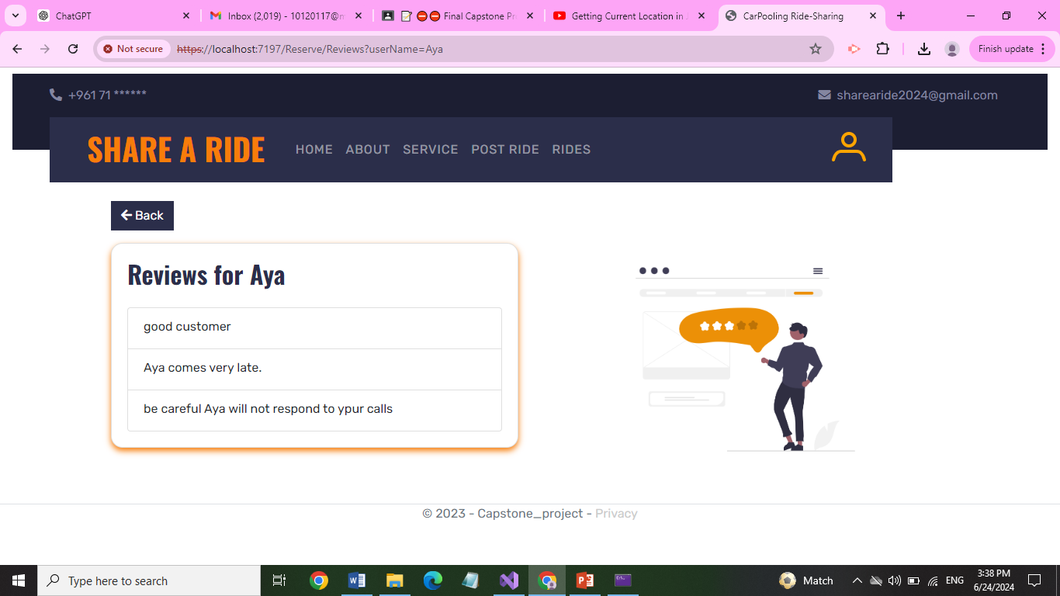

Figure 21 Rider's reviews Page

Figure 20 shows the driver history of each user. Each user can view the reservations of his ride and he is able to accept or deny the reservation. In addition, he is able to filter the reservations by status (Accepted/Pending) or search for a specific reservation by user name that will facilitates his work. In addition, the user can view the reviews of people who reserved his ride after clicking on the orange message button as shown in figure 21 and write a review about the rider after finishing the ride to benefit other drivers.

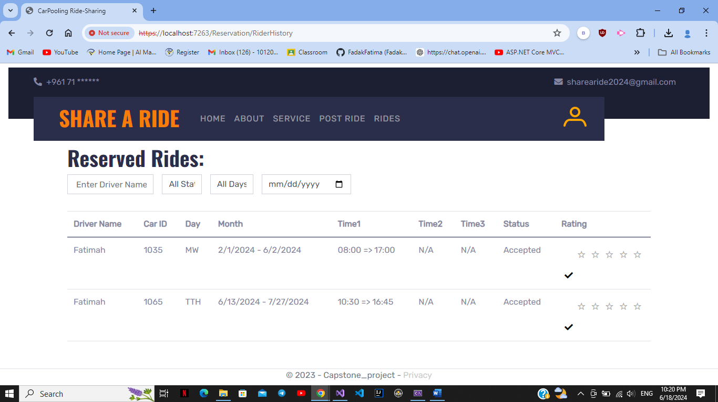

Figure 22 Rider's History Page

Figure 22 shows Rider history. In this page the user is able to see the rides that he had reserved before with the information that is related to the ride (time/month/days.) and see if they are accepted/denied or still pending. He is also able to filter those reservations by days, status, date, and driver name to facilitate his work. Moreover, he is able to rate the ride he went with.

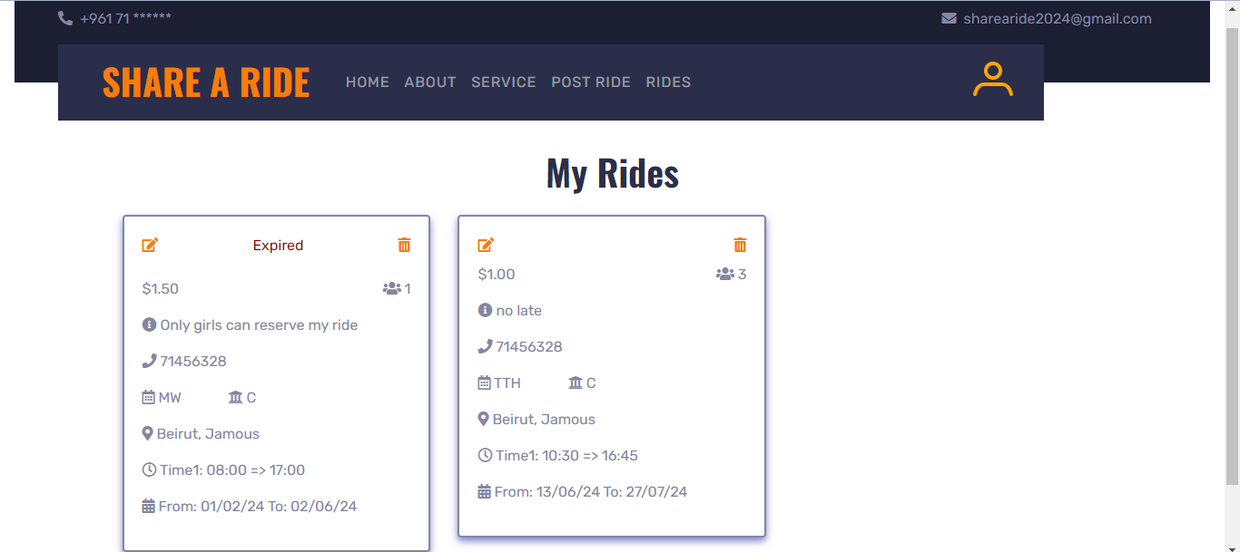

Figure 23 My Rides Page

Figure 23 shows my rides page. In this page the user is able to view the rides he had posted; he is able to delete his ride or even edit and update the information of his rides.

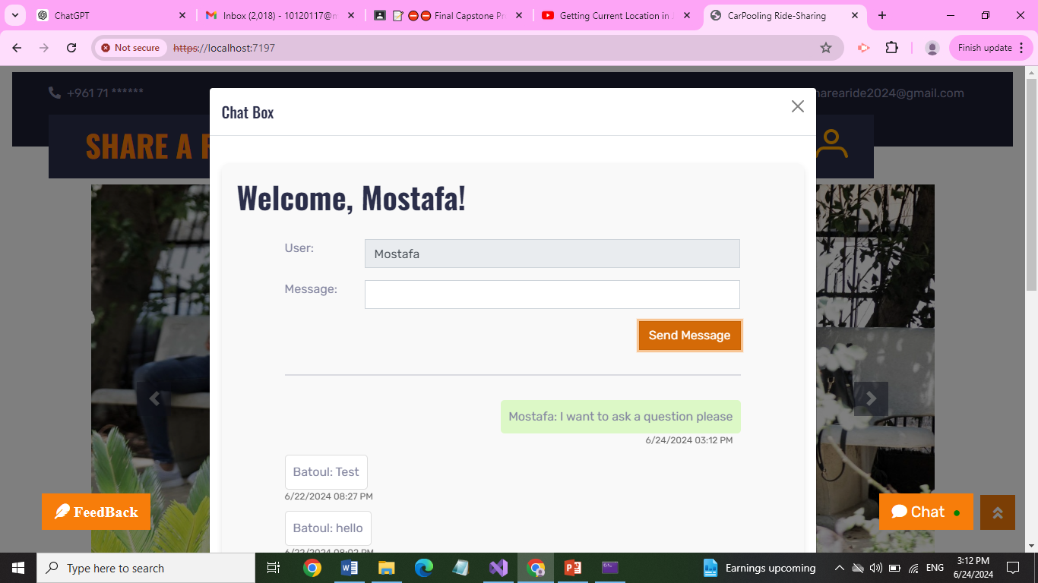

Figure 24 Chat Page

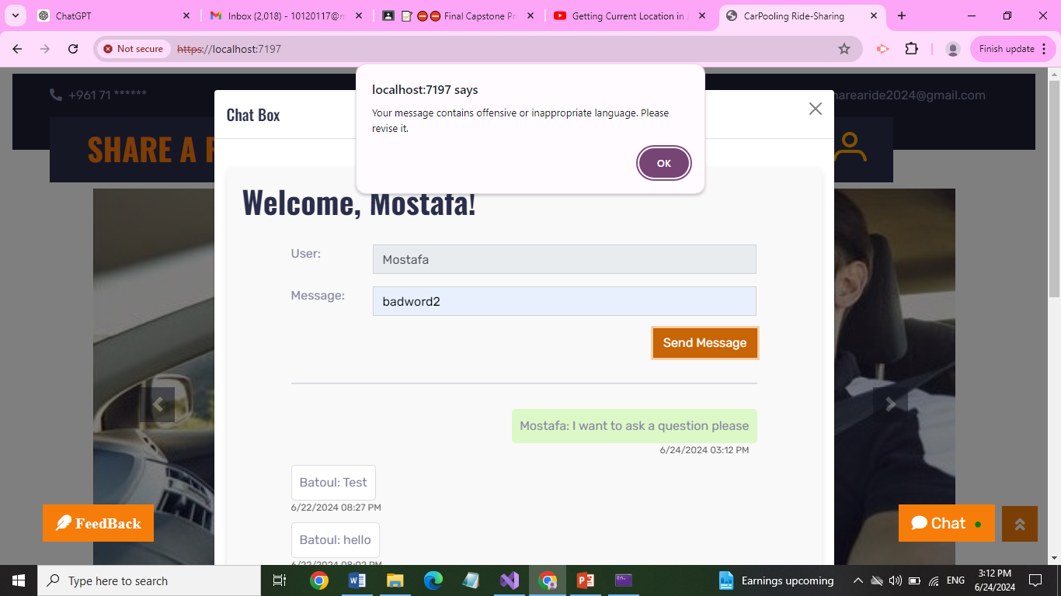

Figure 25 Chat Page + Warning

Figures 24 shows the chat page of the website, where users are able to send and receive messages from other users. Figure 25 shows that the user is not able to write offensive or bad words and when he tried to write such words a pop-up message will appear for him and his message will not be sent until it is an appropriate message. This is done for having more security while chatting and for a tack in talking.



Figure 26 Chat Notification

Figure 26 shows that when the user is online and new messages are sent, a green circle appears to notify him about the new messages.

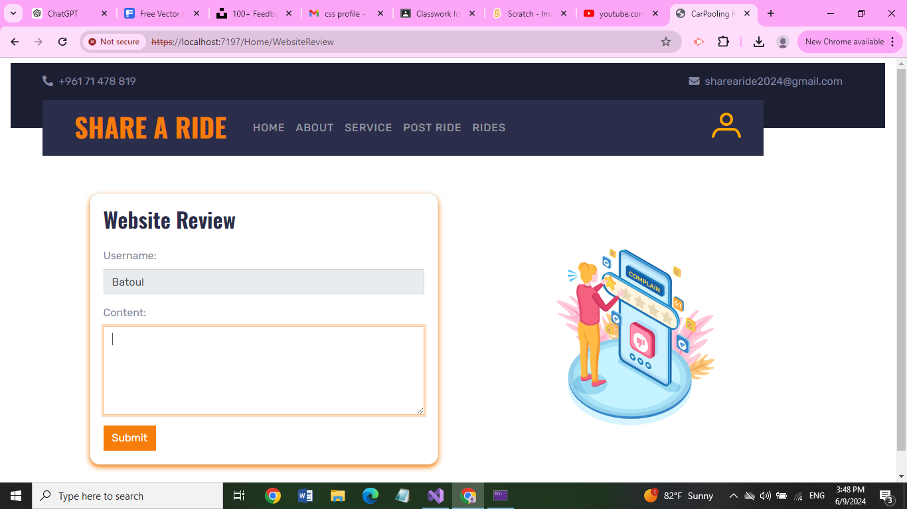

Figure 27 Feedback Page

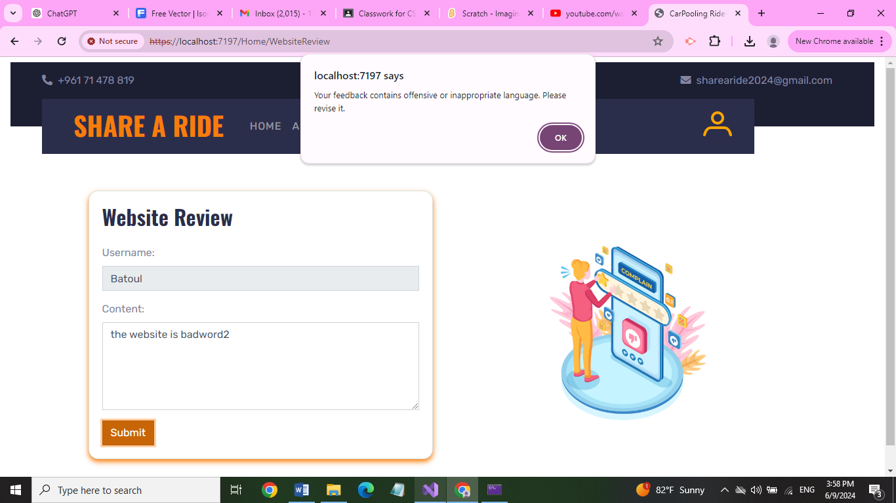

Figure 28 Feedback warning

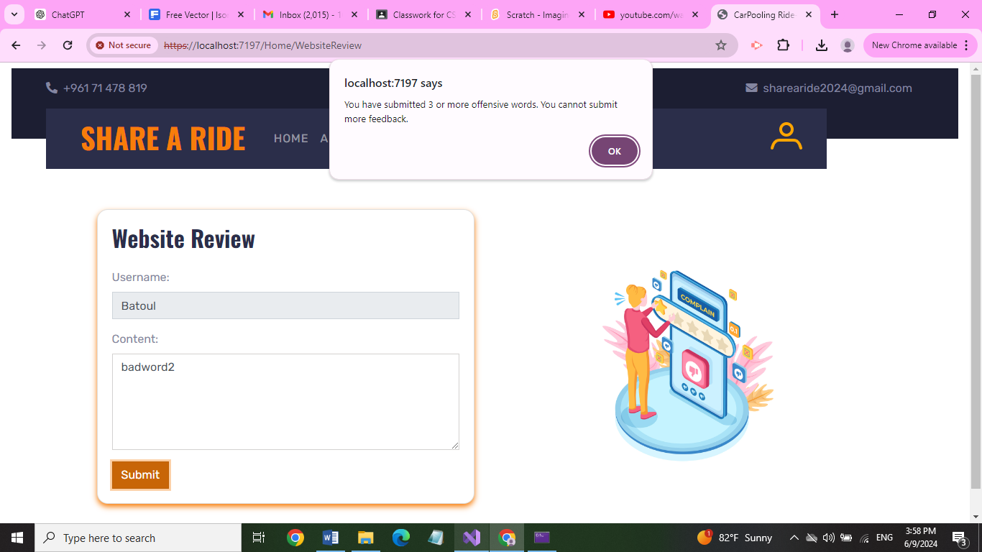

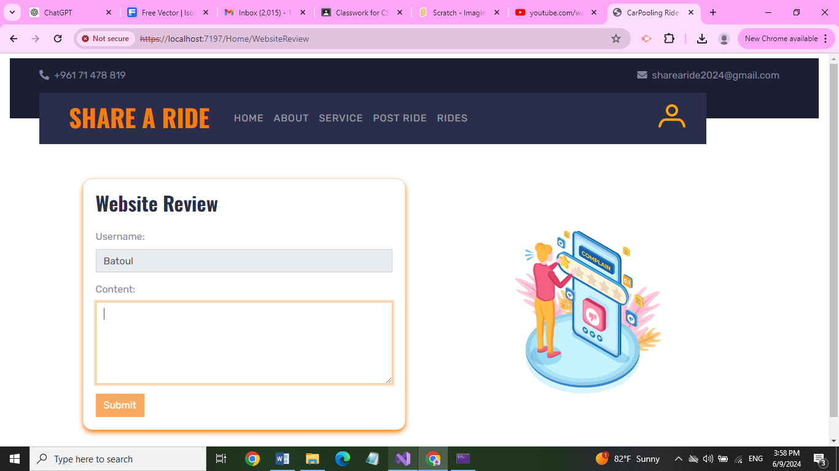

Figure 29 Feedback after three warnings

Feedback page is shown in figure 27 where the user is able to write his opinion and experience in our website. For more security and as shown in figures 28 and 29 the user cannot write any bad or inappropriate words since the feedbacks are visible to all users. After giving the user three warnings he will not be able to write any feedback again and the submit button is blocked for him. The user must write his opinion even if it is negative but in respectful way.

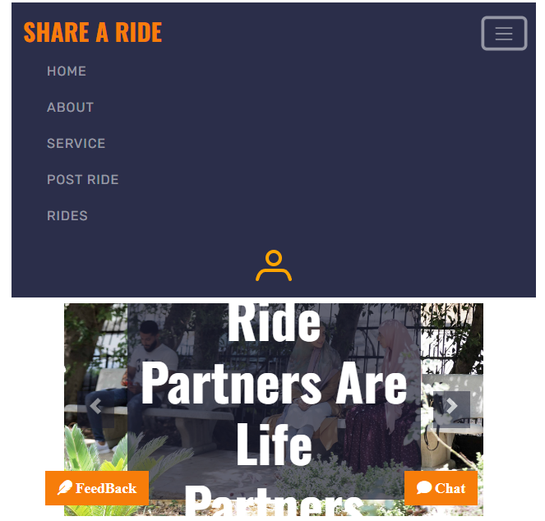

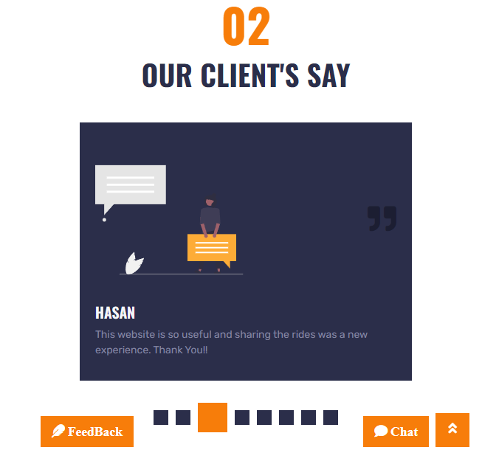

Figure 30 Responsive Website

The above figures shows that our website is responsive. It is designed to allow the user to have an easy experience in our website and provide an optimal viewing and interaction experience across a wide range of devices, from desktop computers to mobile phones. This means the website automatically adjusts its layout, images, and other elements to fit the screen size and resolution of the device being used, ensuring usability and readability without the need for manual resizing or scrolling.

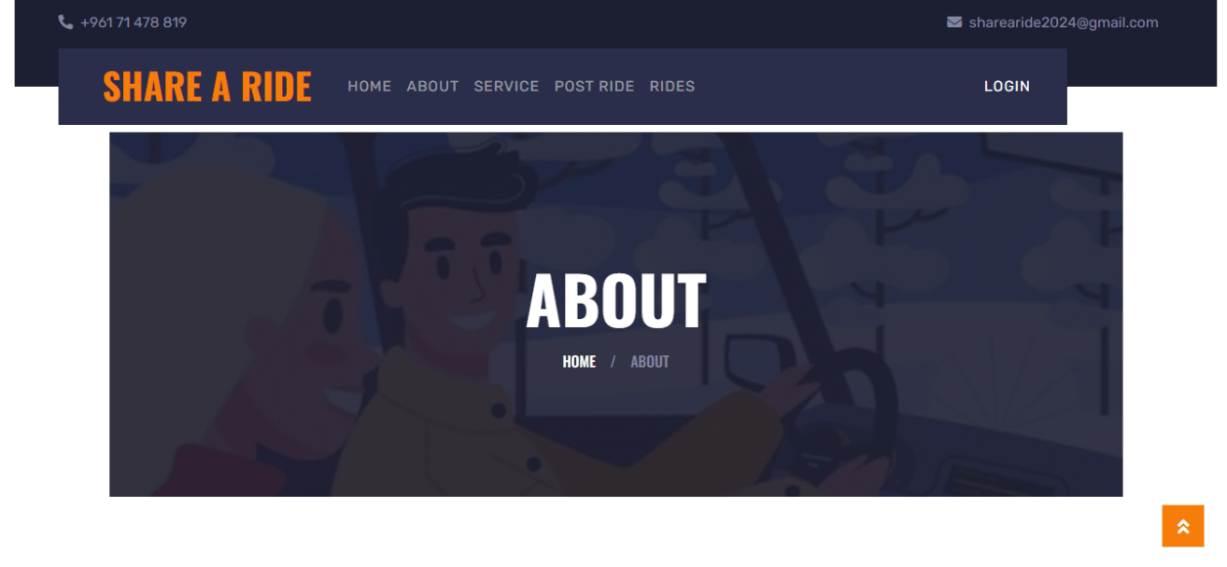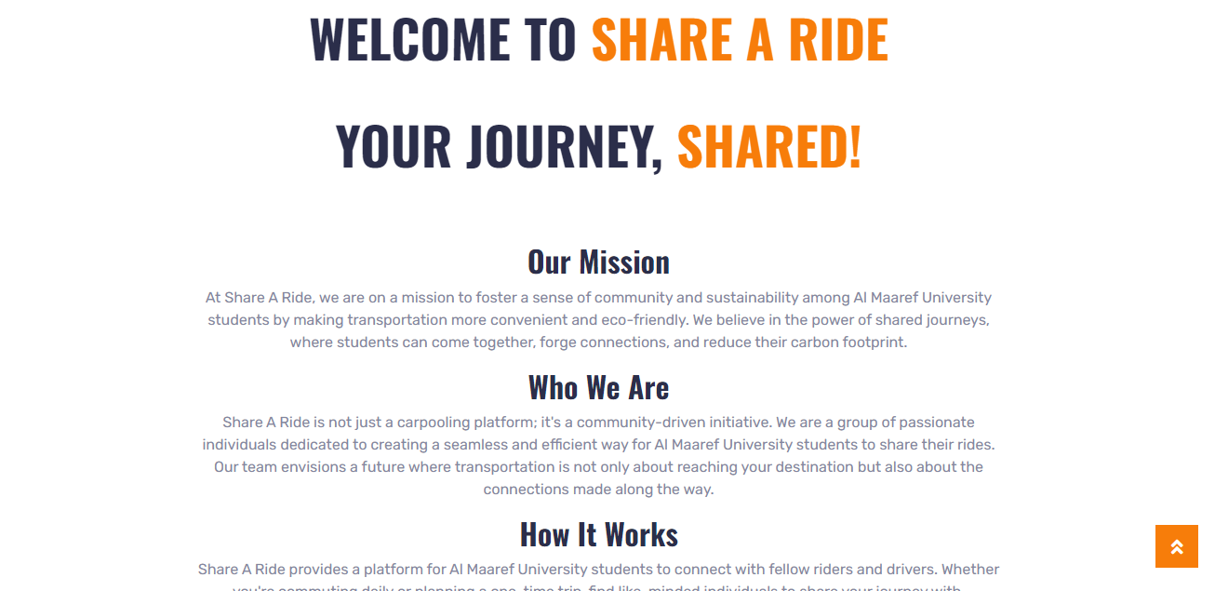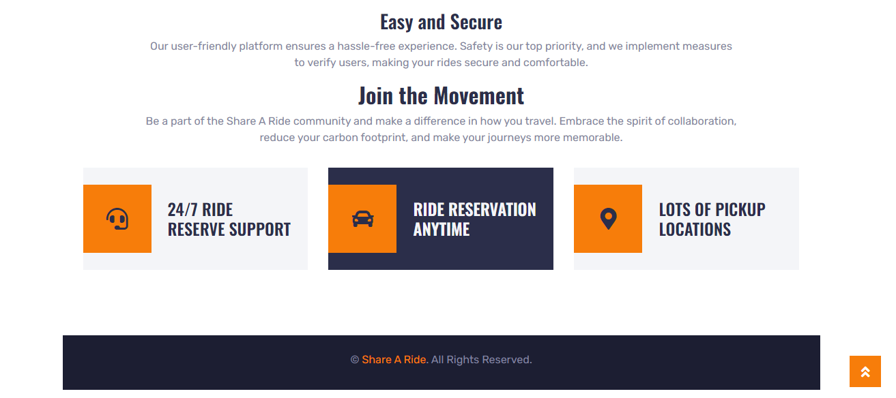

Figure 31 About Us Page

This page provides more information about the website and about the people who made the website.

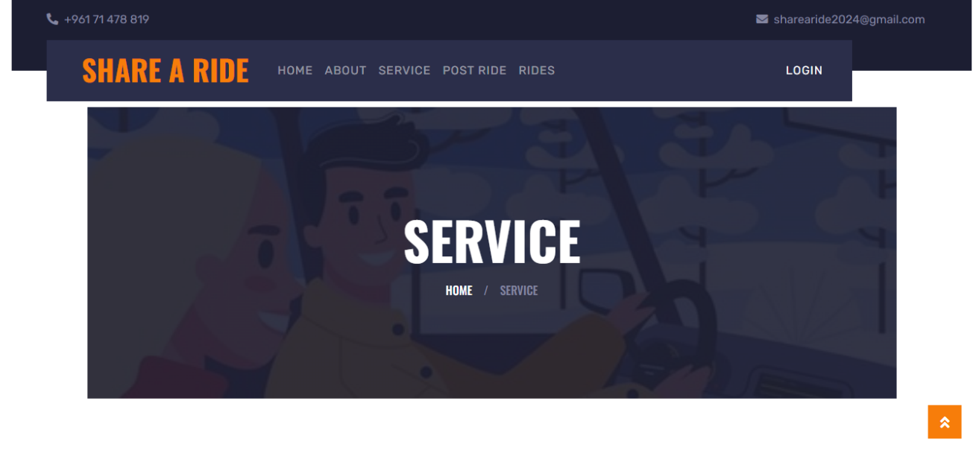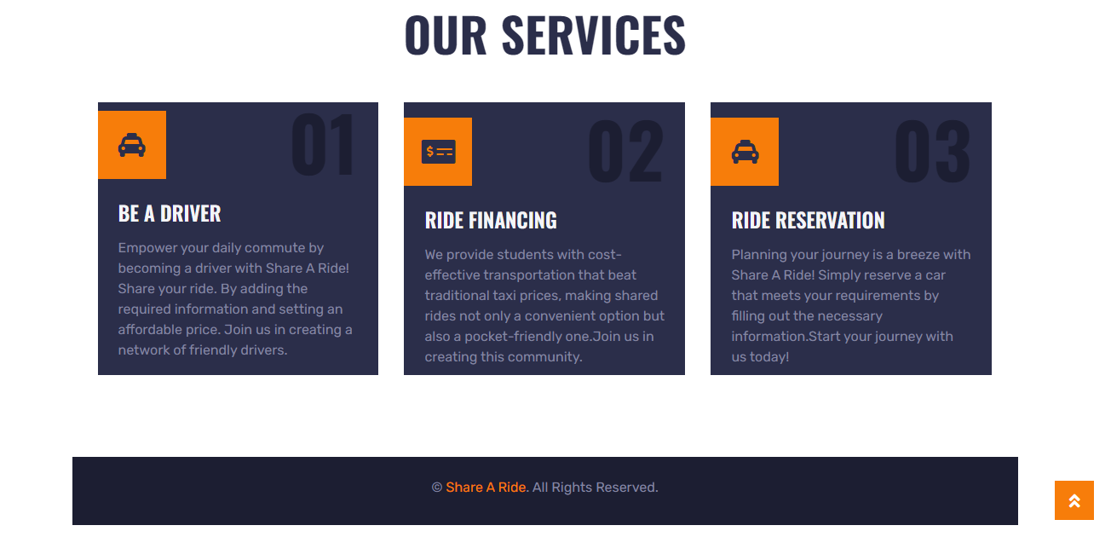

Figure 32 Services Page

The services page is dedicated to detailing the various services offered by our website. This page typically provides visitors with comprehensive information about what the website does. It shows the users the what we offer in our website and how can they benefit from using it.

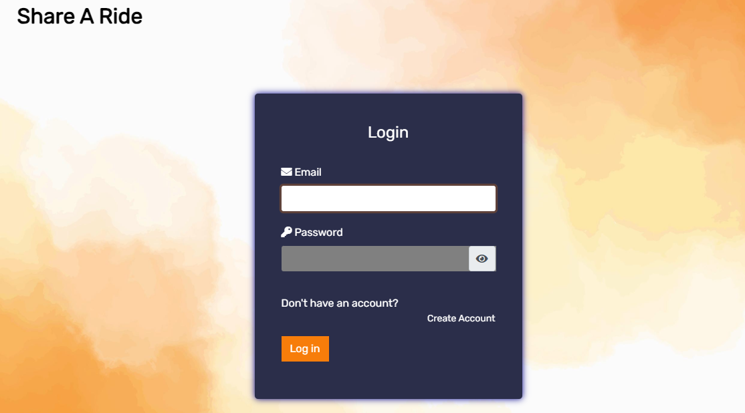

Figure 33 Login Page

Our website contains Login and register pages. The login page allows the user to write his email and password and check if they are correct to login. If one of them is incorrect the user will be notified (Shown in the below figure).

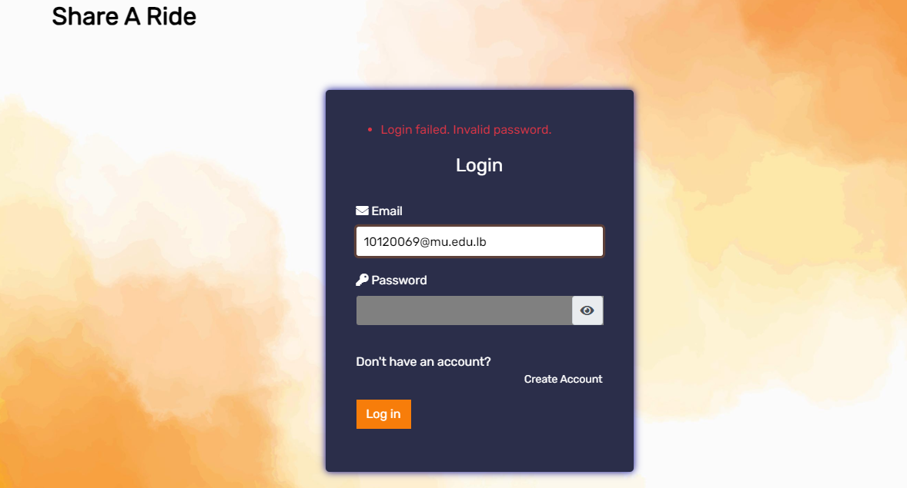

Figure 34 Invalid Login

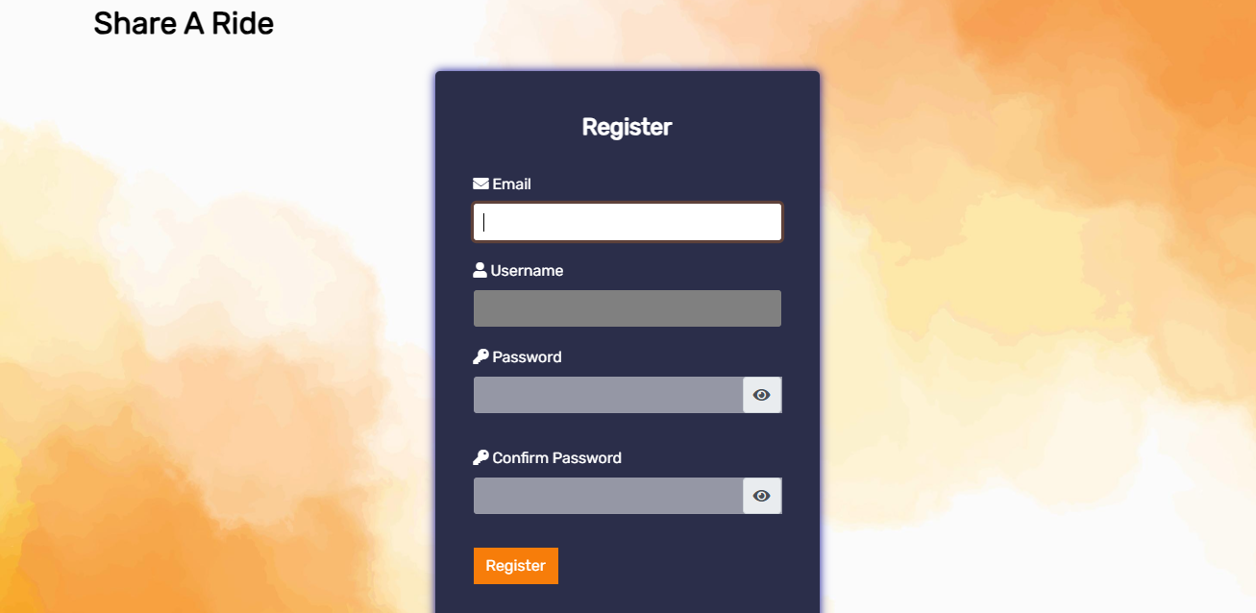

Figure 35 Register Page

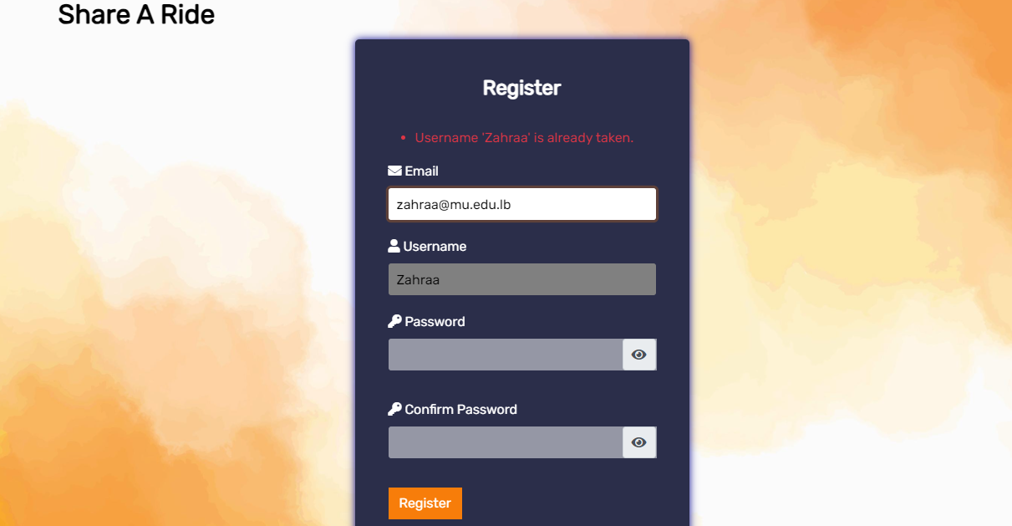

Figure 36 Register (User Name exists)

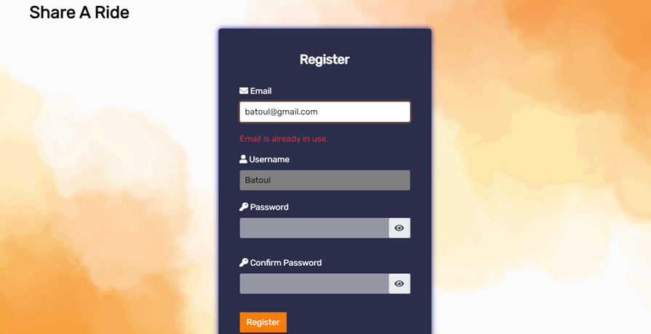

Figure 37 Register (Email Exits)

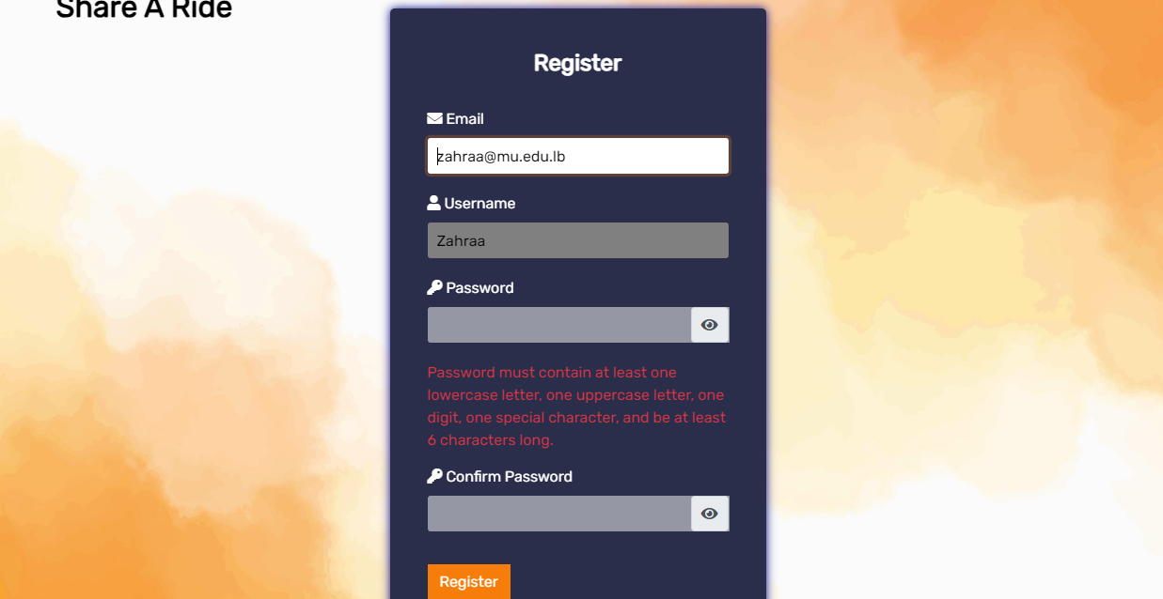

Figure 38 Password Restrictions

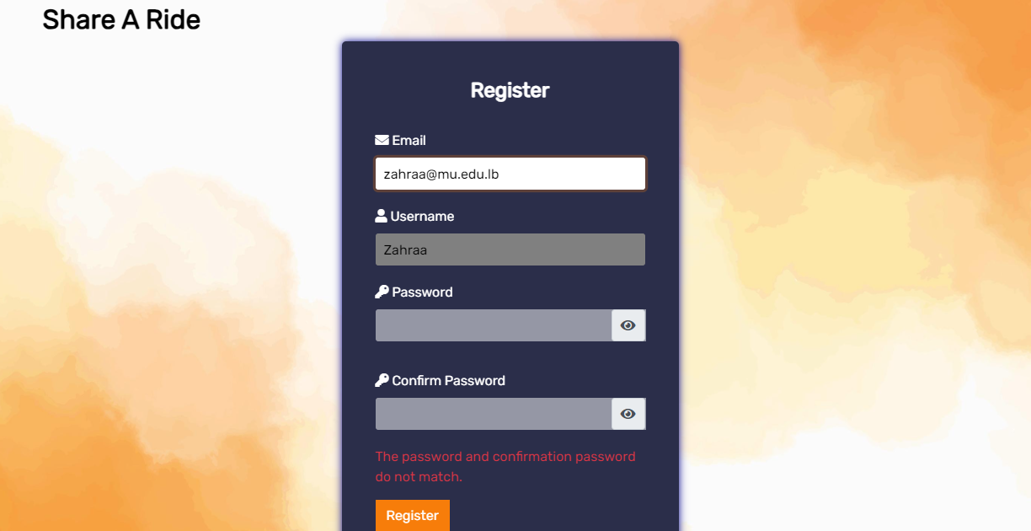

Figure 39 Confirmation Password

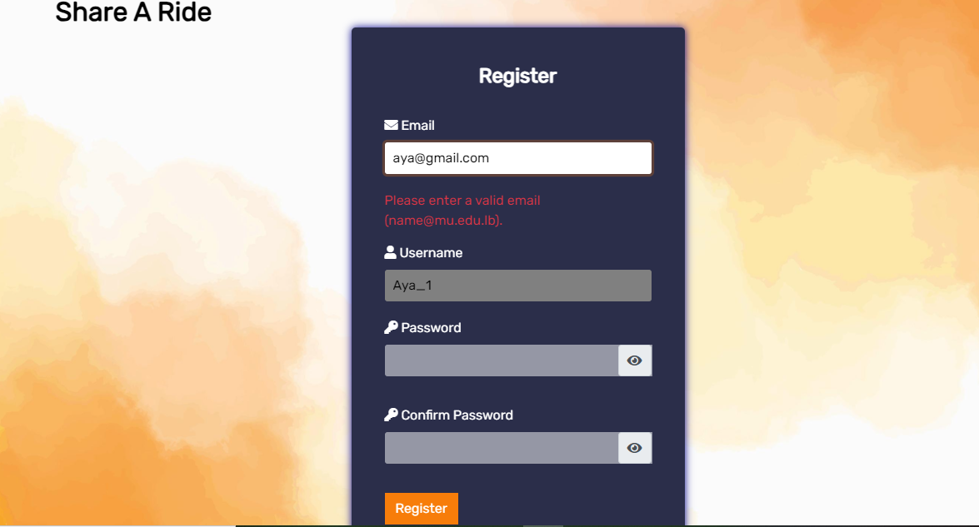

Figure 40 Invalid Email

In the register page, the user enters his email, username and password. The system checks if the email or username already exists so that the user will not be able to use them and register as shown in figures 36, 37. Email should be a mu.edu.lb email to make sure that it is only for Al-Maaref university students for more security as shown in figure 40. In addition, password have several conditions to be accepted which are:

* It should contain at least one uppercase letter to ensure a mix of lowercase and

Uppercase characters.

* It must have a minimum of six characters to guarantee a certain degree of

Complexity.

* It should contain digits to increase the security of the password.
* It should contain at least one special character.

In addition, our register form contains confirm password input that checks if password and confirmed password are the same. It is done to make sure the user writes the password he wants to use.

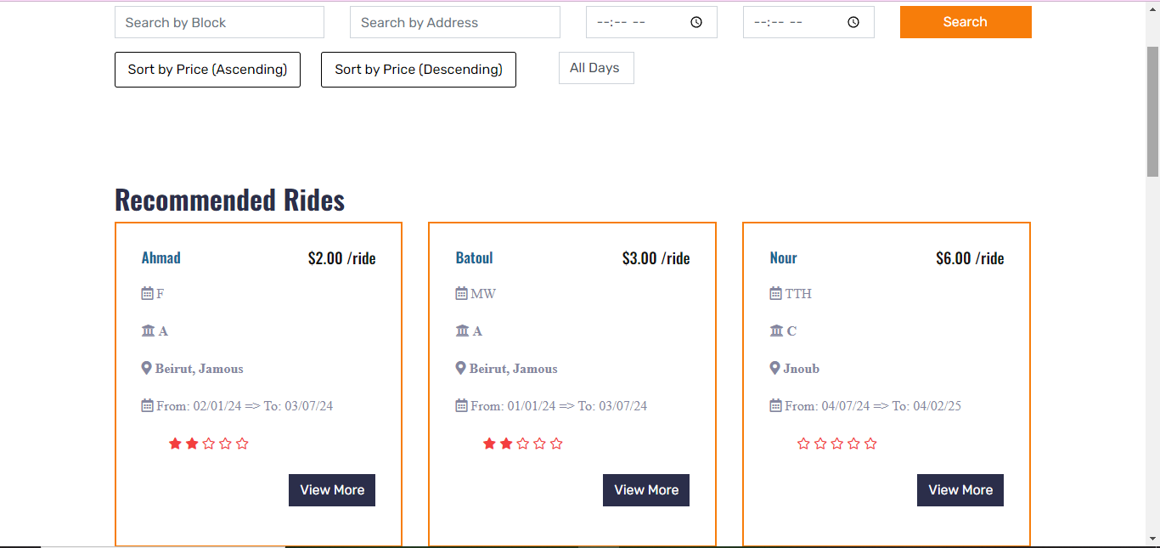

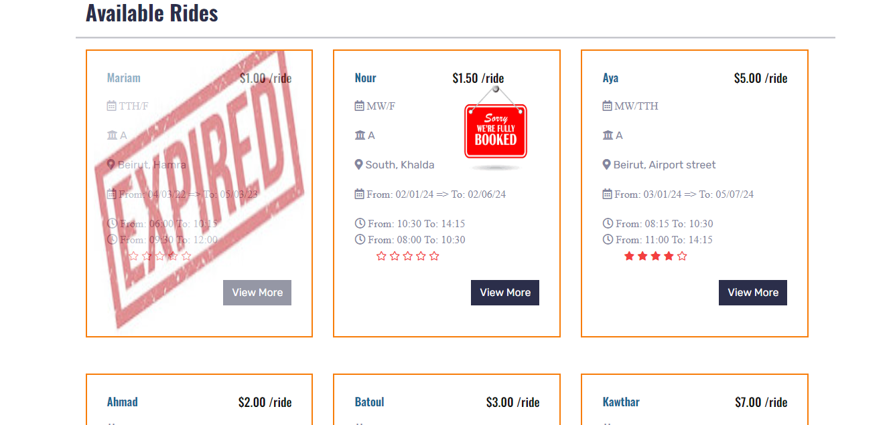

Figure 41 Rides Page

Our ride’s website page contains the recommended rides and all available rides. The user is able to search for a specific ride by address, block, start time and end time. Moreover, user is able to filter the days and filter by price ascending or descending. The search and filter features are applied on the available rides only, recommended rides will still appear the same.

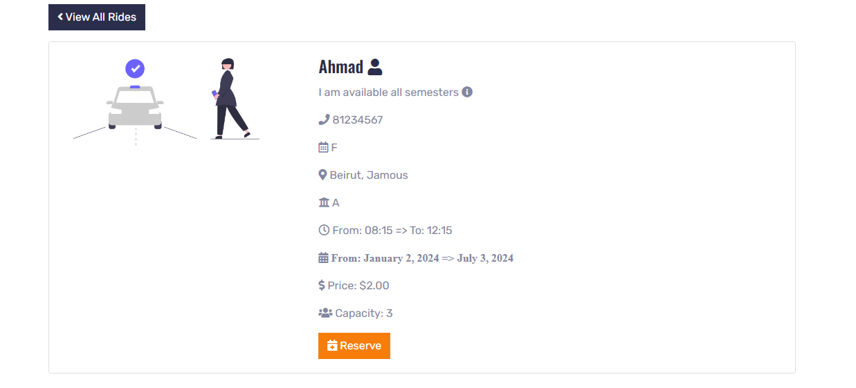

Figure 42 View More page

By clicking view more, the user will be able to see the detailed information of the ride and he will be able to reserve the ride by clicking on reserve button if the ride is not fully booked, since the reserve button will not appear if the ride is fully booked as shown in figure 43.

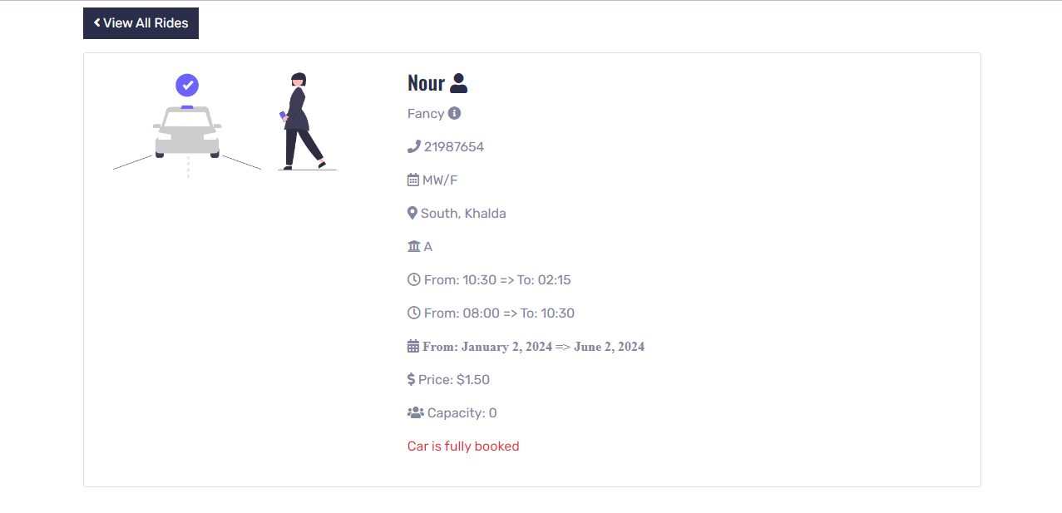

Figure 43 View More for fully booked ride

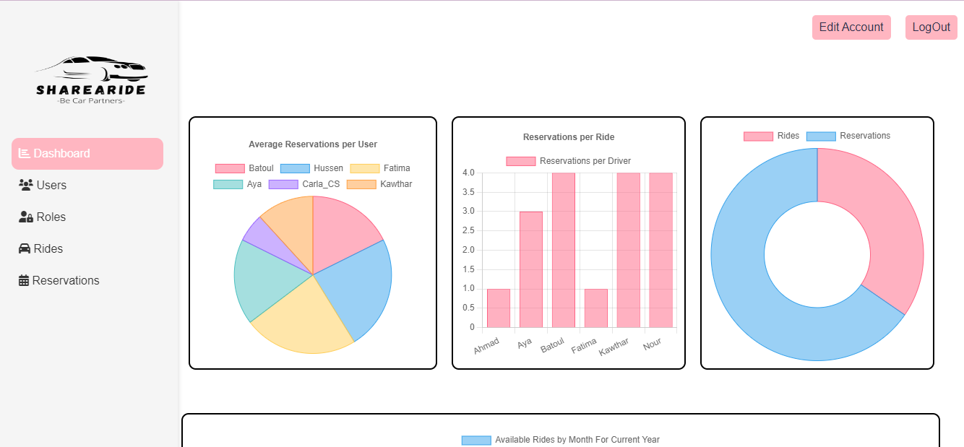

Figure 44 Admin Dashboard page

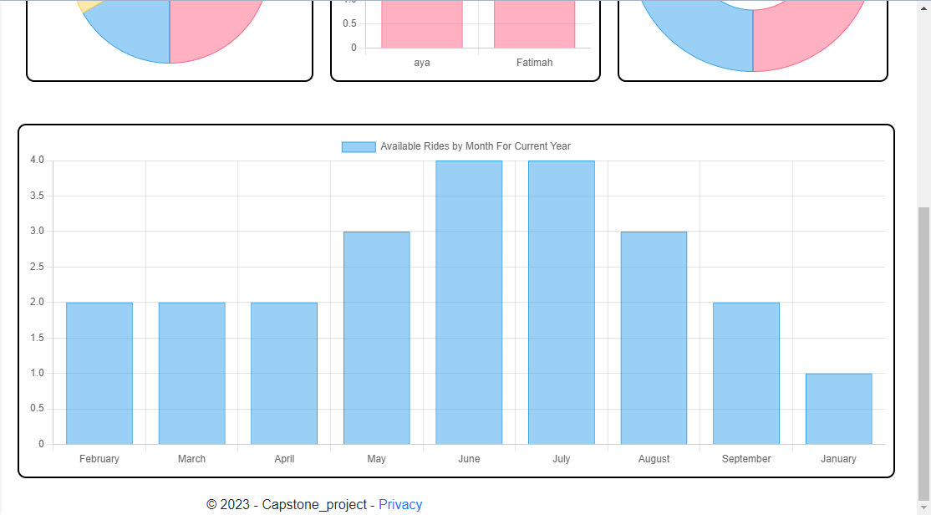

Figure 45 Admin Dashboard page-2

The figure above (44-45) shows the view of the admin side when he logged in. The navbar contains logout and edit account buttons. It is the dashboard where it displays the analysis of the website including a bar for the number of rides, number of reservations, a bar for reservations per ride (each driver how much he had reservations), a bar for the average of reservations per user (each user how many reservations he had done) and a bar for the available rides for the current year per month.

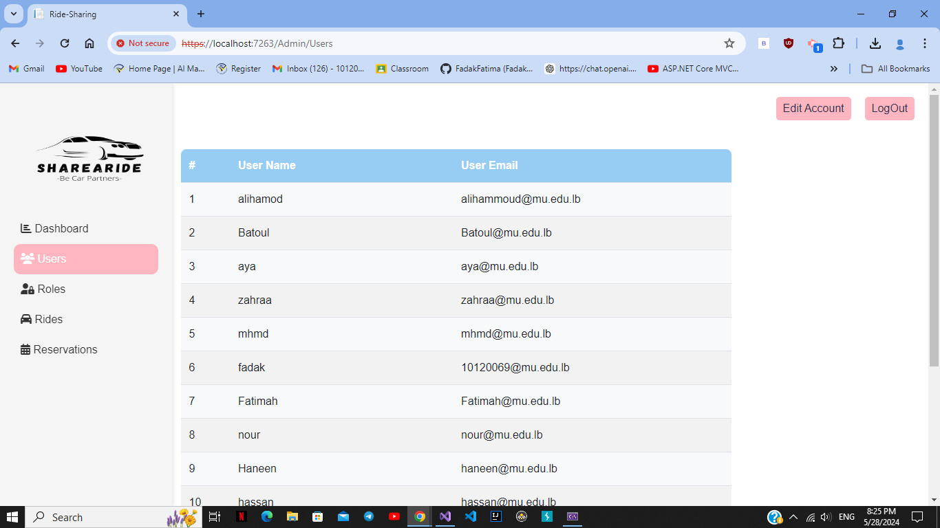

Figure 46 Users page

The figure above shows the users of the website (user name and email) with the total number of them.

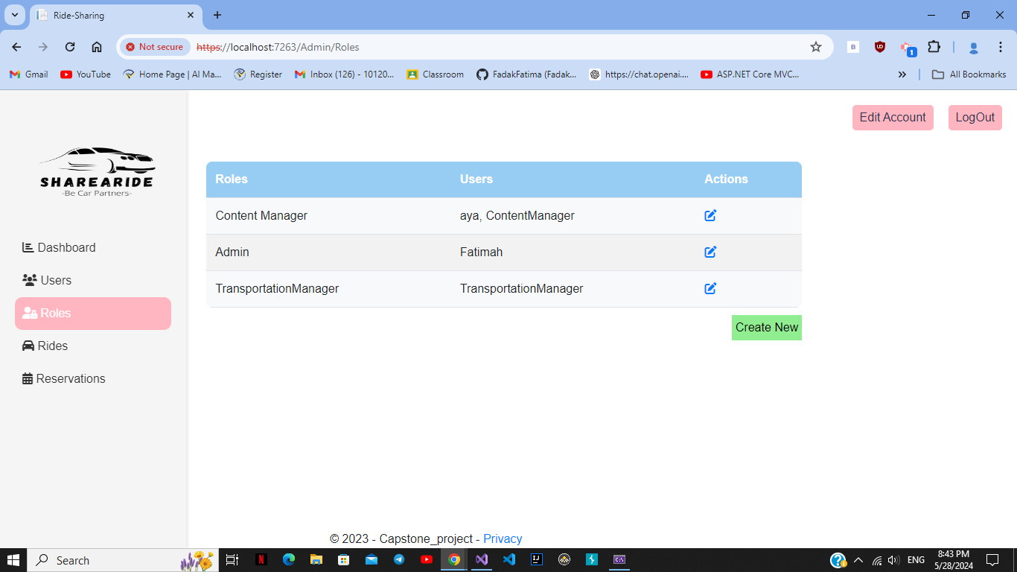

Figure 47 Roles page

The figure above shows the available roles in the website with the name of users for each role with a create new button that allow only the admin to create a new role or edit the old ones.

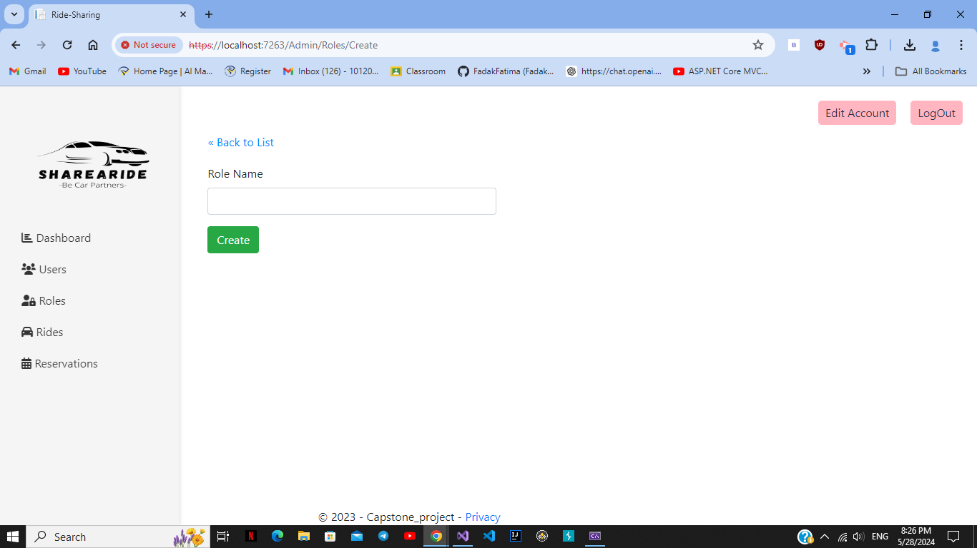

Figure 48 Create Role page

The above figure shows the view of creating a new role.

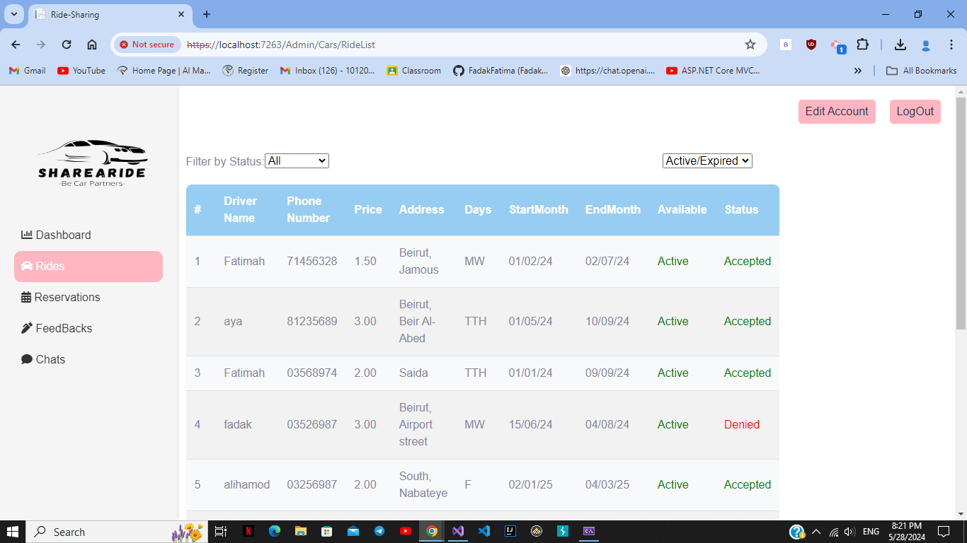

Figure 49 Rides page

The figure above (49) shows the list of rides in the website with two filters one for the status (accepted/pending/denied) and one for the availability (expired/available).

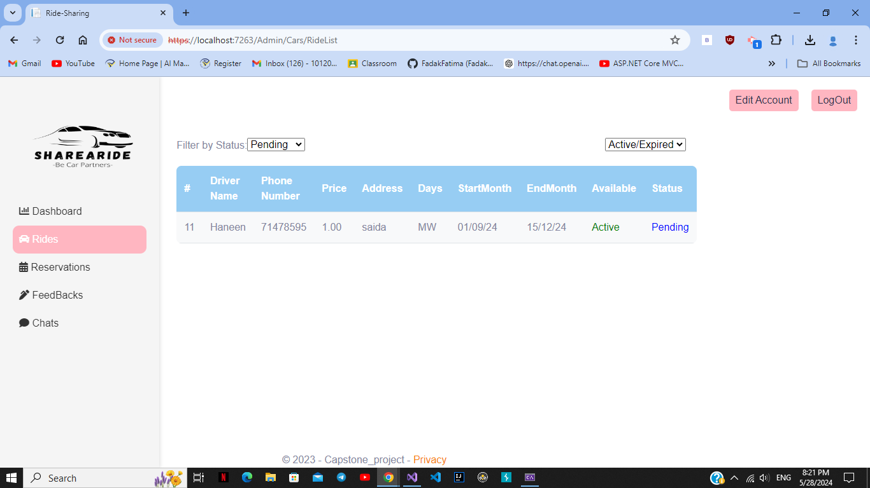

Figure 50 Filtering for Pending rides

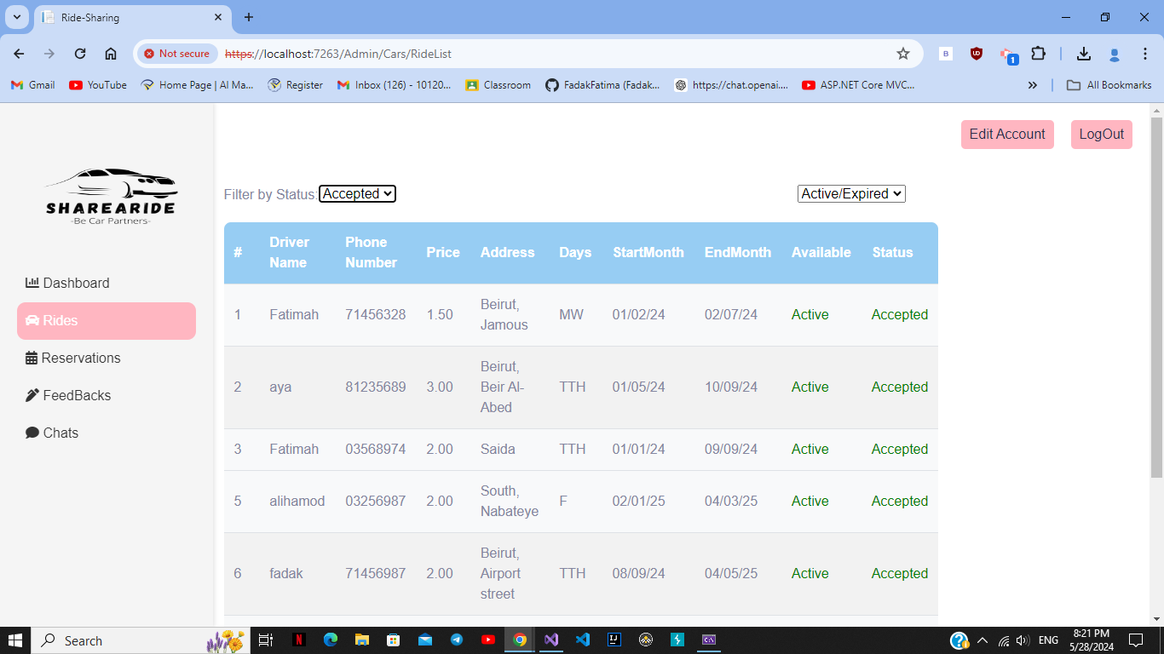

Figure 51 Filtering Accepted Rides

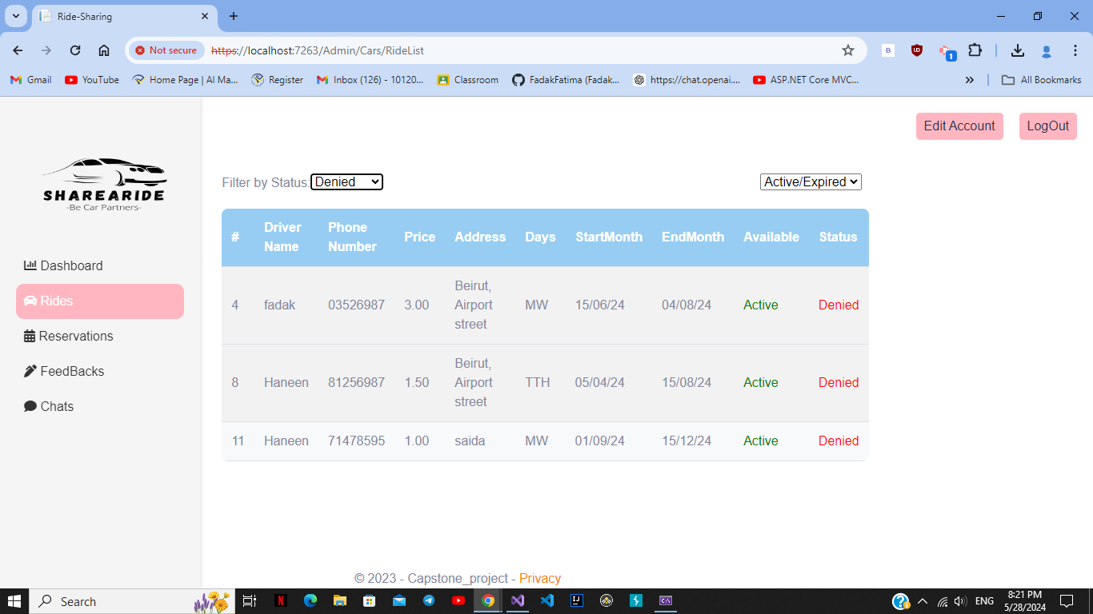

Figure 52 Filtering Denied Rides

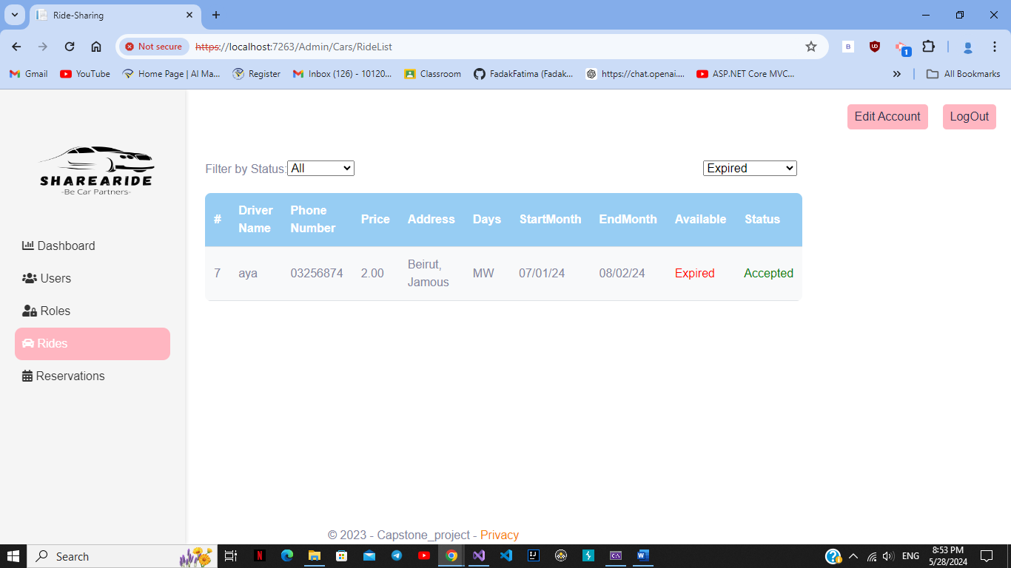

Figure 53 Filtering Expired Rides

The figures above (50-51-52-53) show the filtering process where when choosing accepted only the accepted rides are displayed and the same for expired/active/denied….

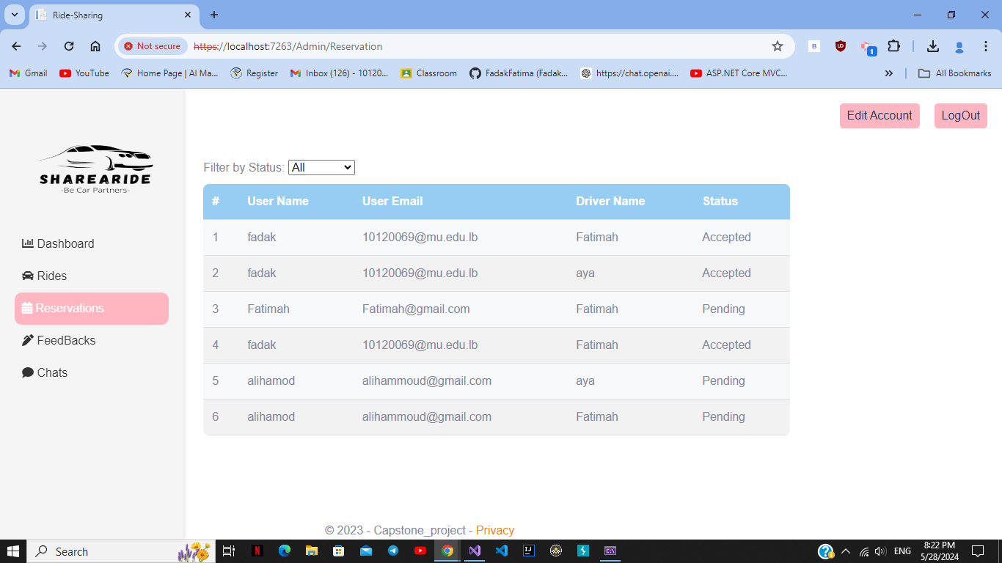

Figure 54 Reservations page

The above figure (54) shows the available reservations with their status if they are accepted/pending/denied.

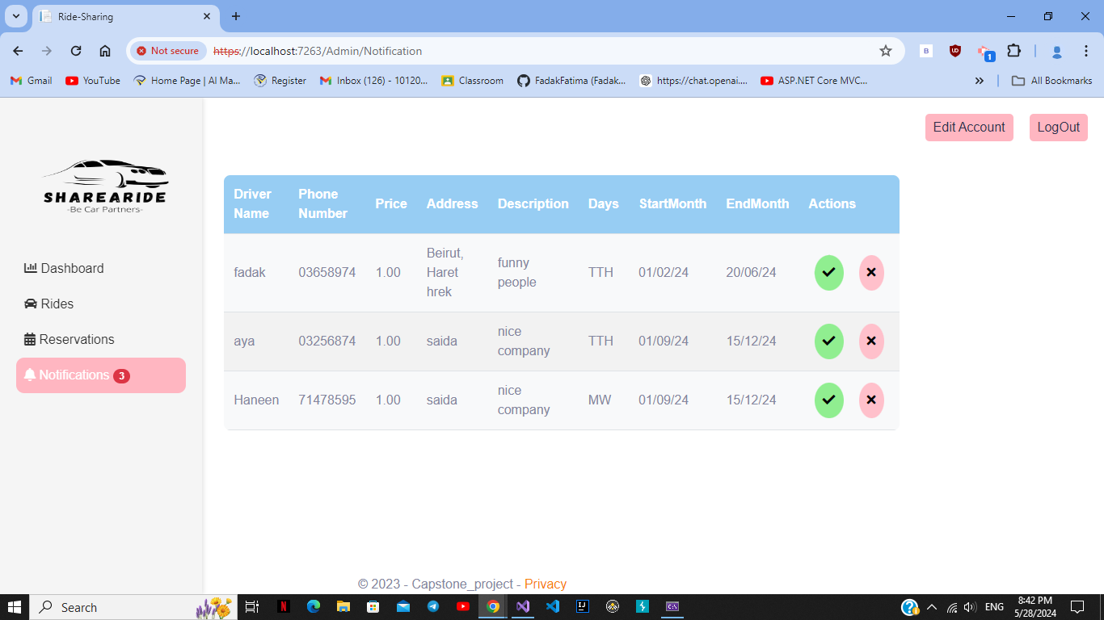

Figure 55 Notification page

The above figure (55) shows the view for the Transportation Manager where when a transportation is logged in it will take him directly to the dashboard view and he can view only rides, reservations and notification views, Notification view displayed the posted rides and the transportations manager is the one who accepts or denied them.

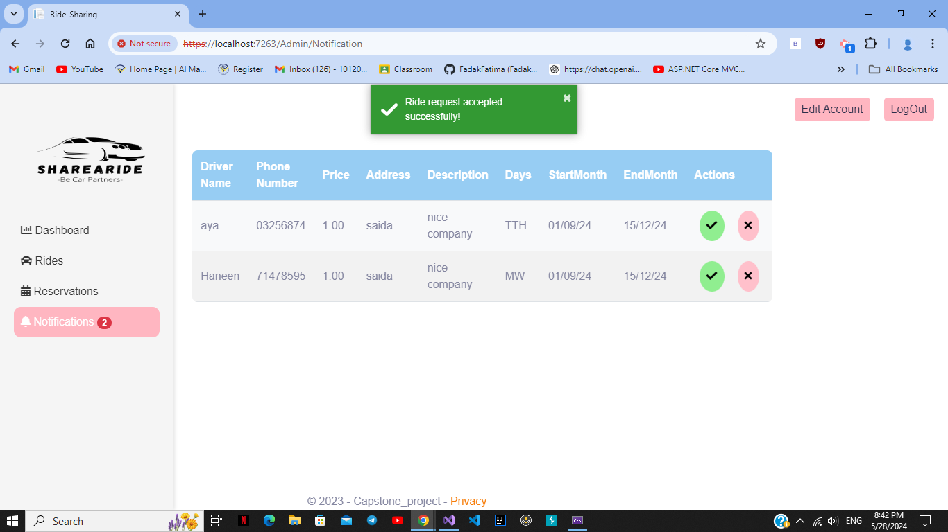

Figure 56 Accepting Ride

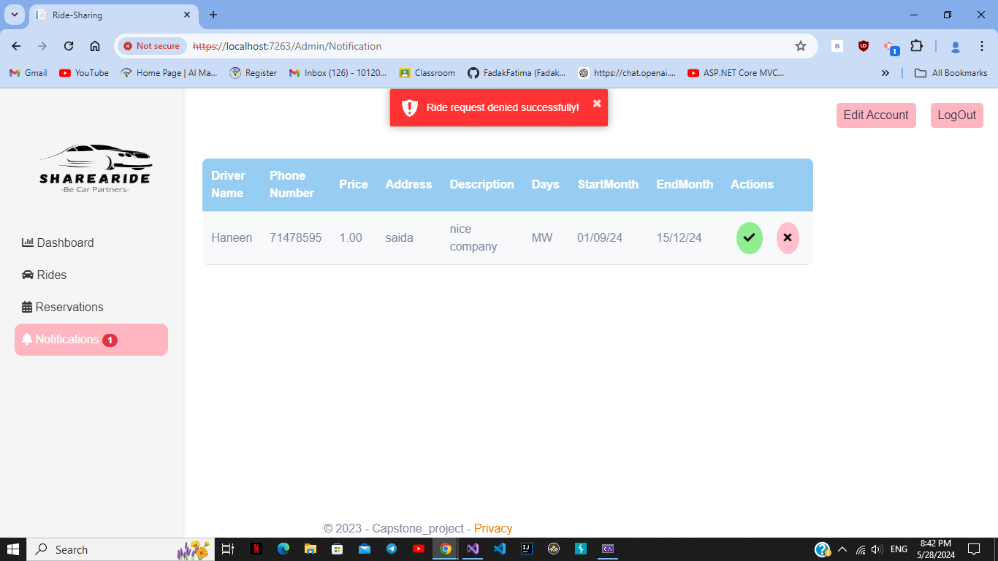

Figure 57 Denying Ride

The figures above (56-57) show the message sent when accepting/denying the rides.

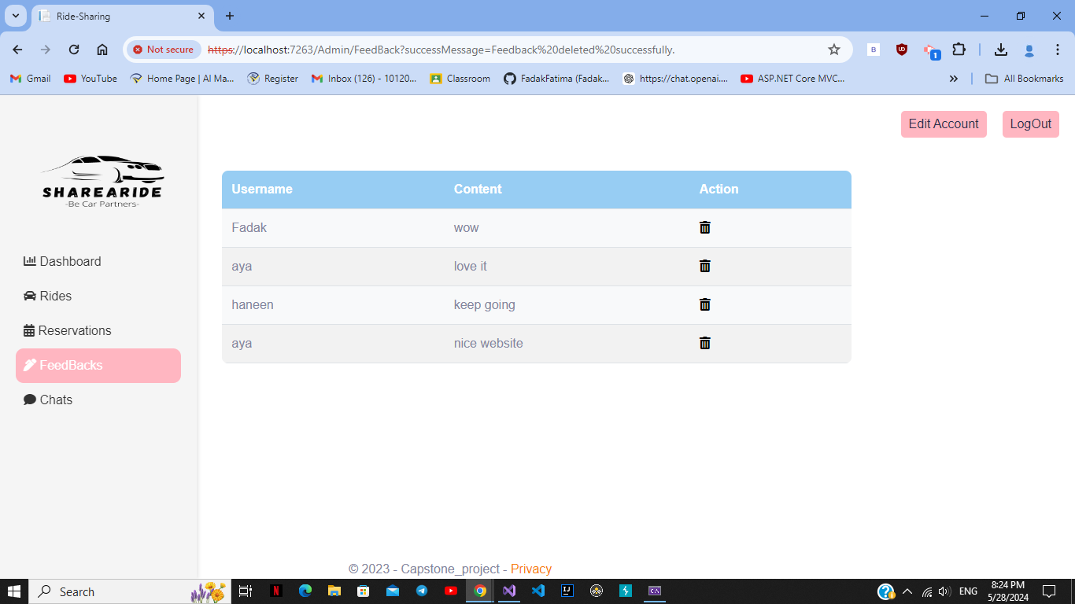

Figure 58 Feed Back page

The figure above (58) shows the users feedback on the website and the only can view them is the content manager role. In addition, the content manager can delete the feedback that have bad or inappropriate words.

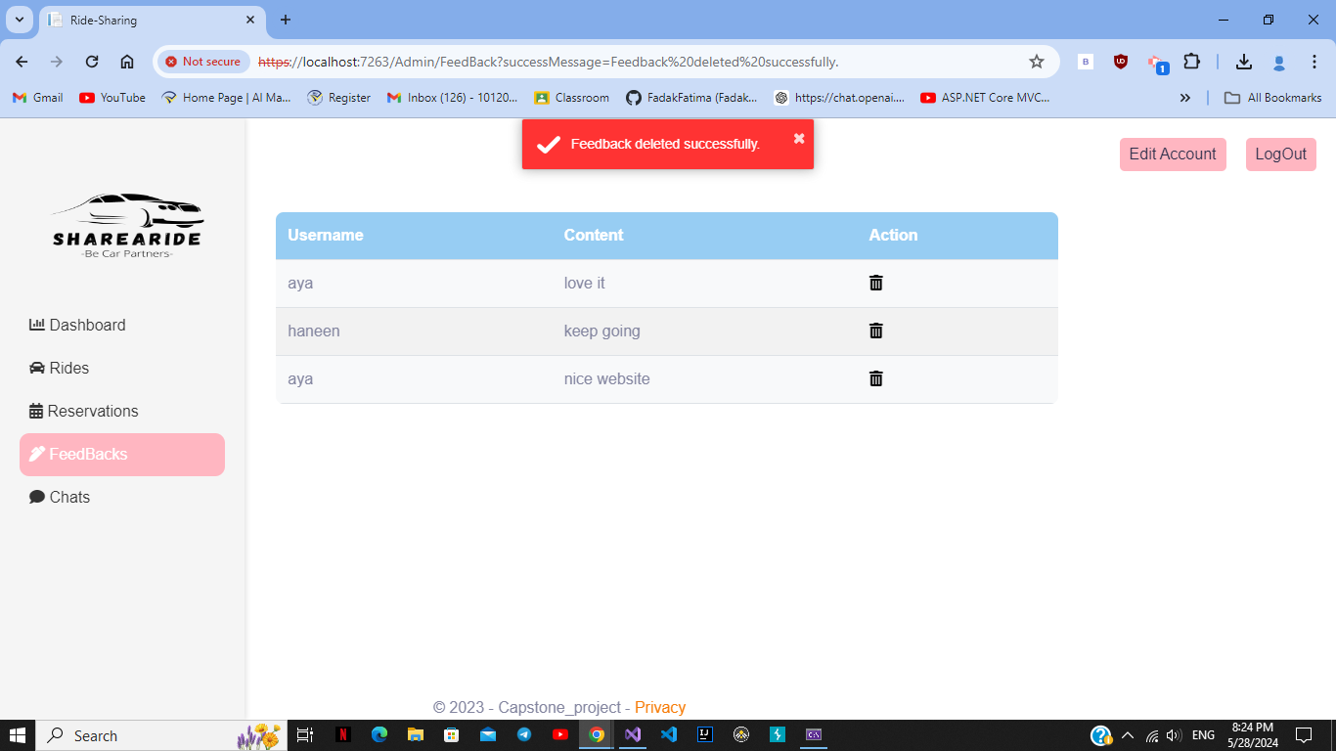

Figure 59 Deleting Feed Back

The figures above show the process of deleting feedback.

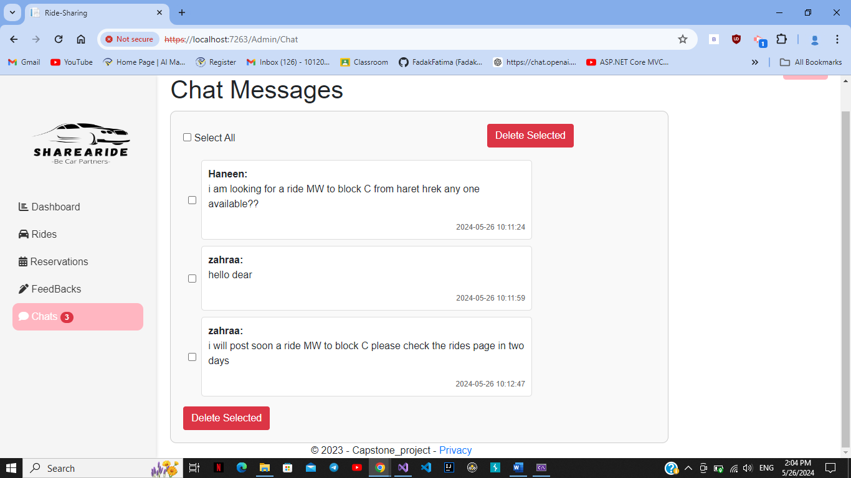

Figure 60 Chat Messages page

The figure above (60) shows the chat messages where it can only be viewed by the content manager and can select the messages he wants and delete them if they are bad or inappropriate.

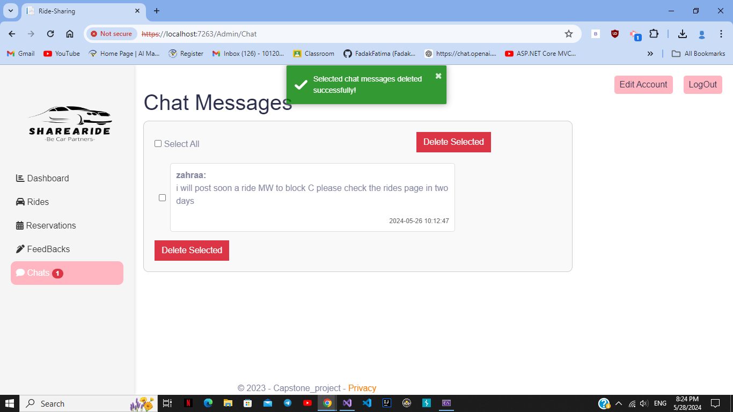

Figure 61 Delete message

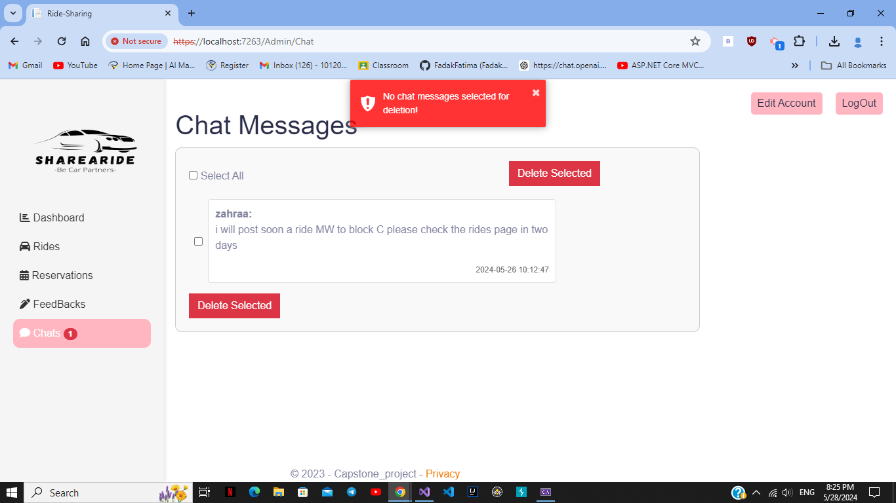

Figure 62 Deleting unselected message

The figures above (61-62) show the process of deleting a message and if the manager press delete button without selecting a message an error is displayed.

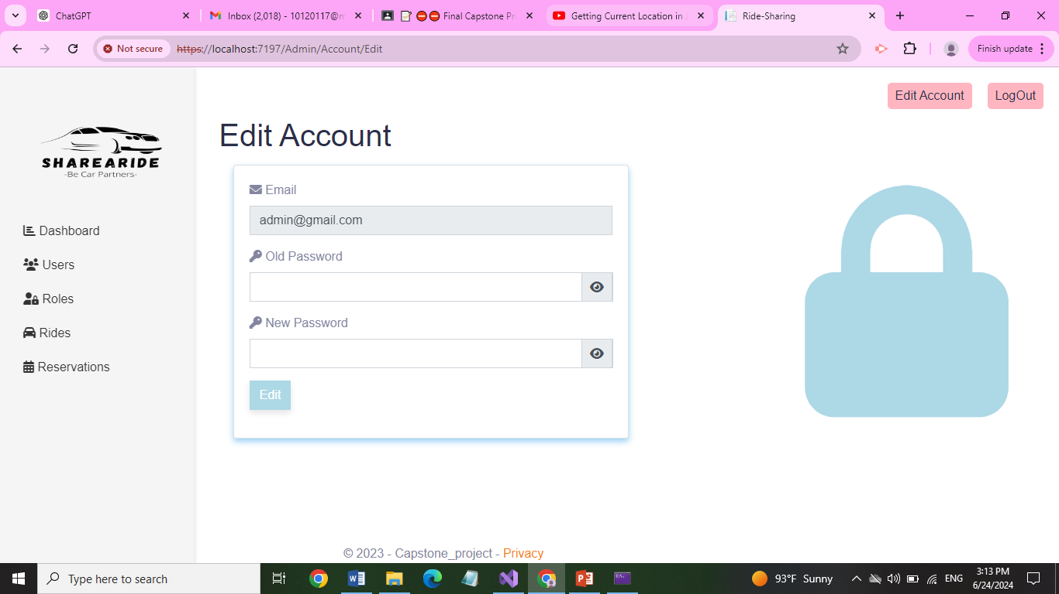

Figure 63 Edit Account page Admin Side

The figure above shows the edit view where the Admin /Content Manager /Transportation Manager can edit their account and change their password.

## **5.4 Code Screenshots:**

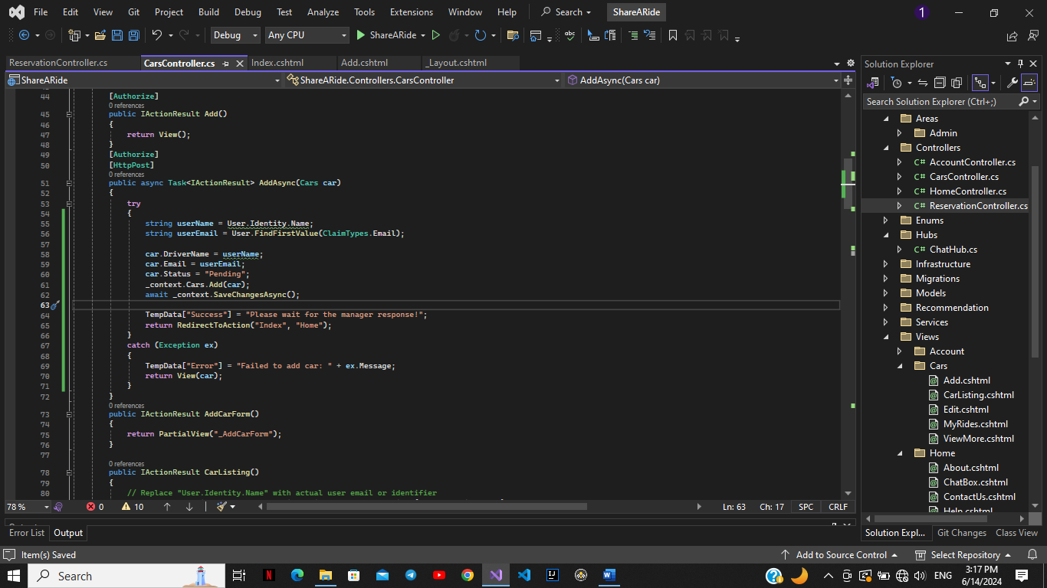

Figure 64 Post Ride Code

The figure above shows the backend code of the Post Ride feature, it takes the username and the email from the users’ data saved from login. Then all posted rides are set as pending in the database waiting for the acceptance from the Transportation Manager. All the entered data in the ride are saved in the database, if any unexpected error occur an error message will be displayed.

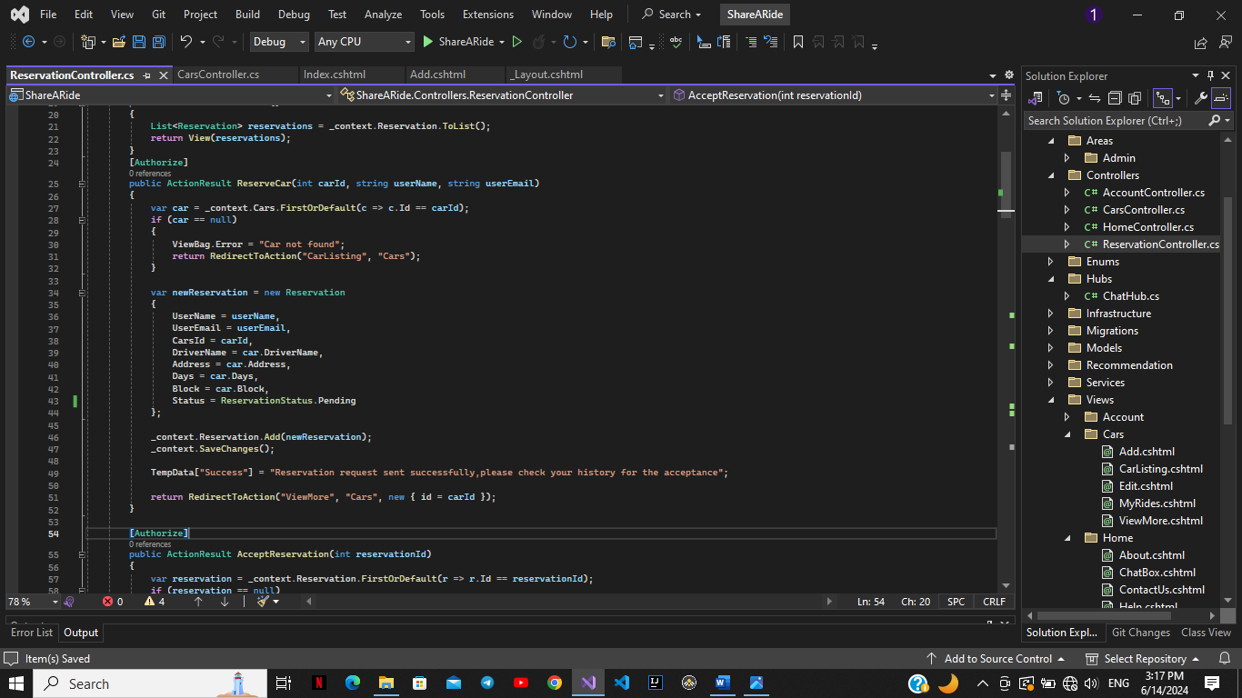

Figure 65 Reserve Ride Code

The above figure shows the backend code of Reserve feature. It checks if the ride (car) is available, if it is not an error message is displayed. Otherwise, the listed information in the code is saved to reservation table in database. The reservation is set as pending and a message is displayed to ensure waiting the driver’s response.

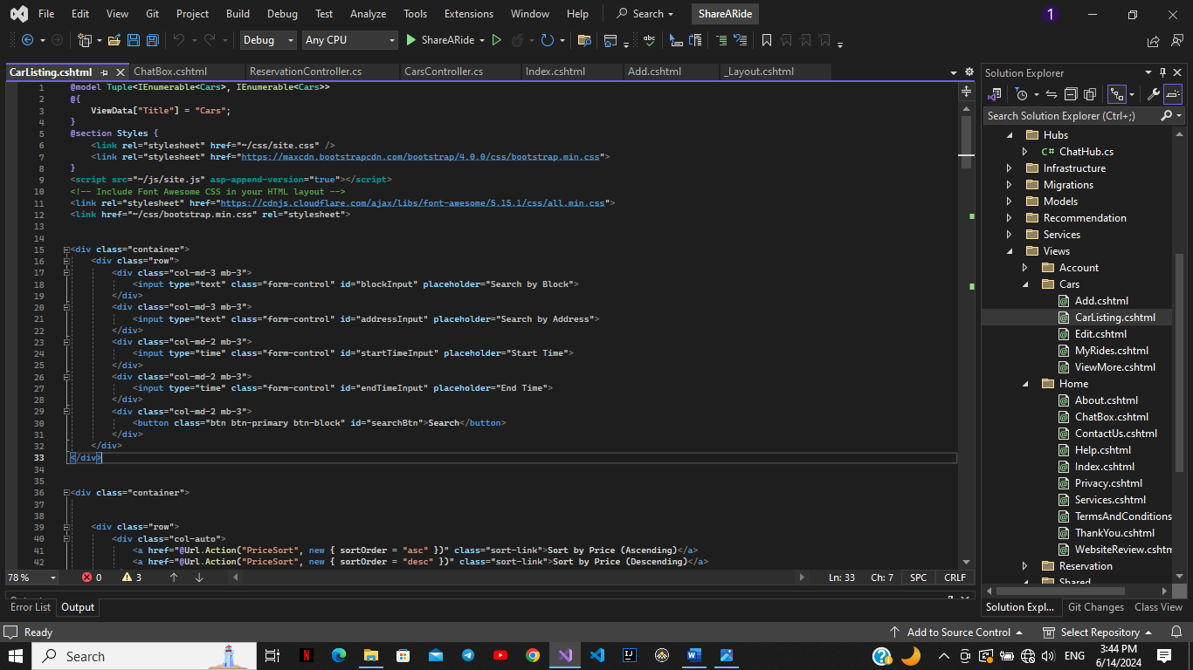

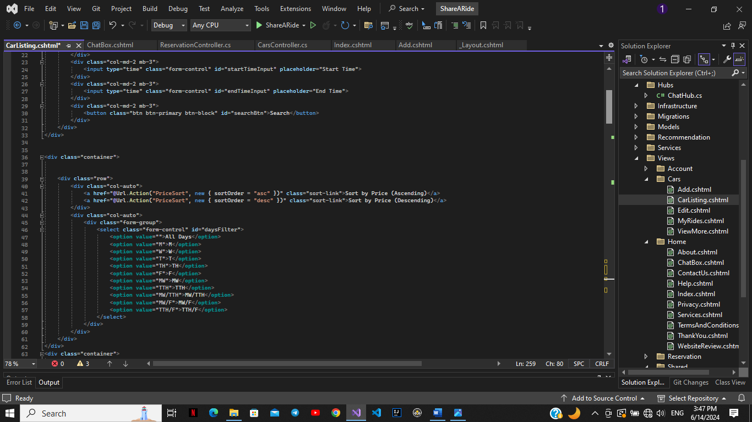

Figure 66 HTML Search code

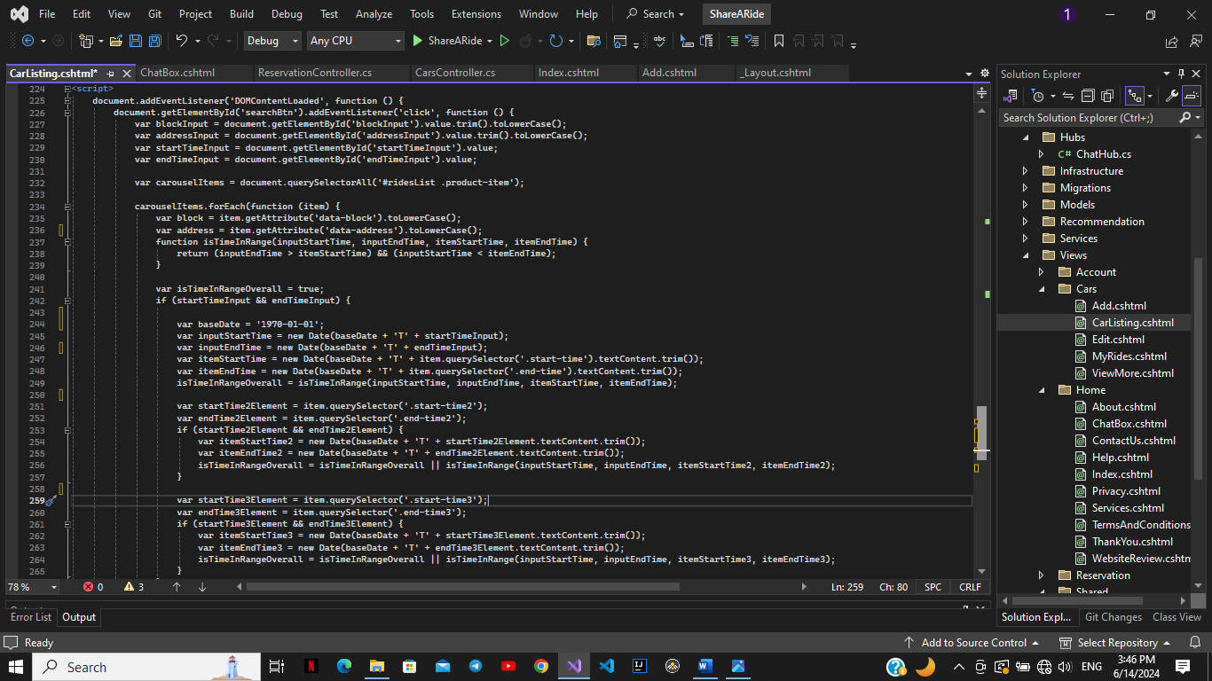

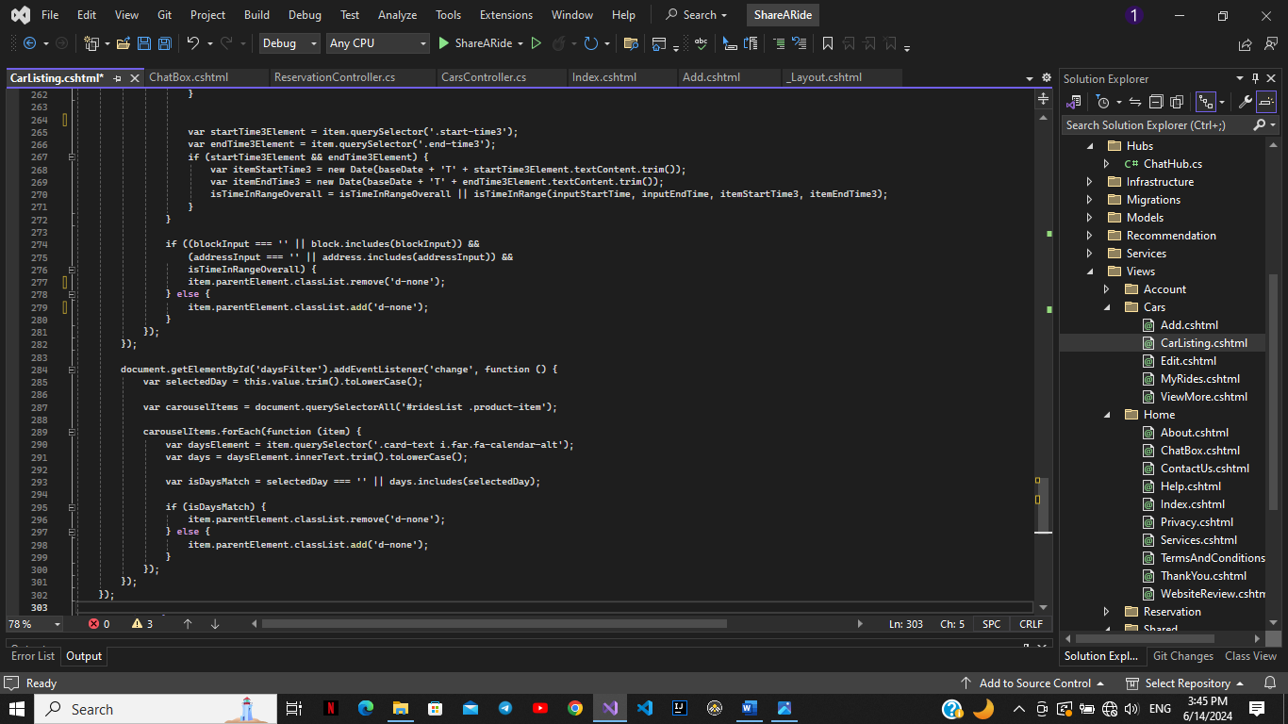

Figure 67 JS Search Code

The above figures shows the search (by block, address and time) and filter by days front-end code including how it is displayed using html, CSS and how it functions using JS.

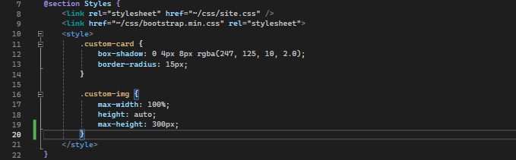

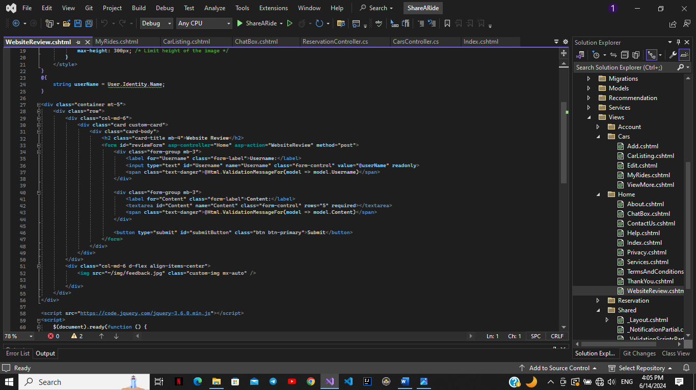

Figure 68 HTML CSS Feedback Code

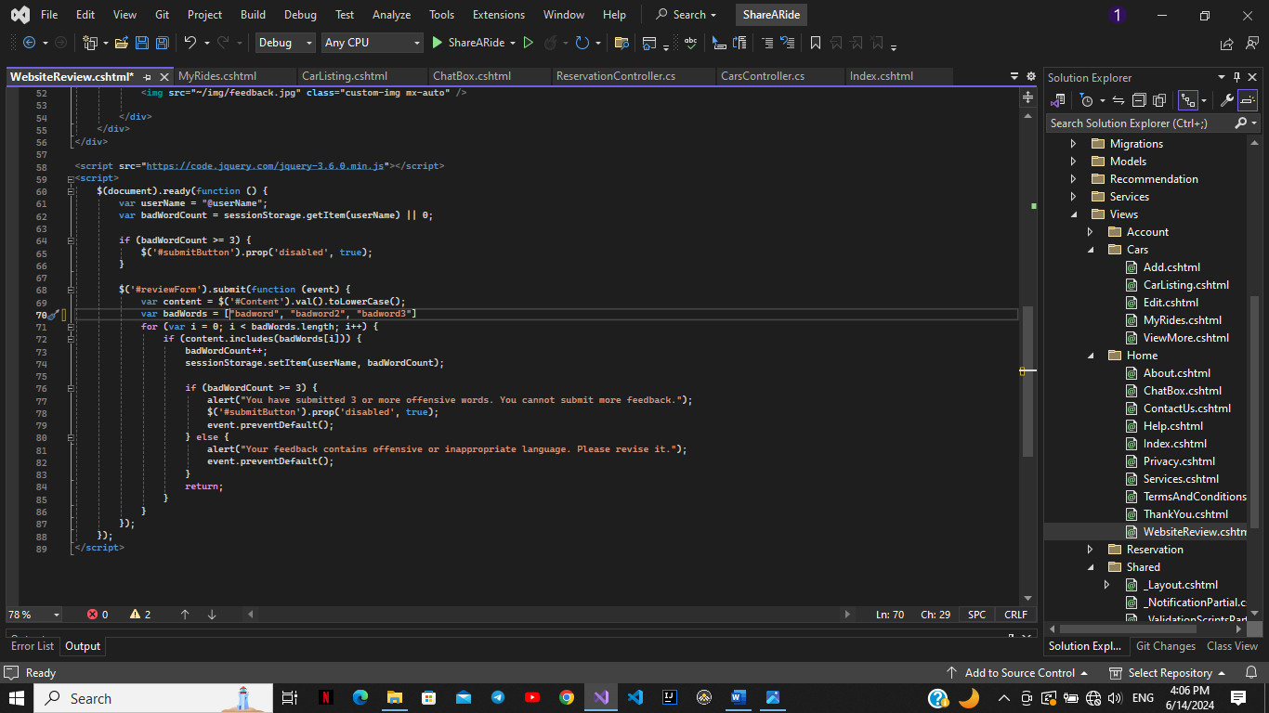

Figure 69 JS Feedback Code

The above figures show the frontend code of the website review. The html, CSS part for the form of the review and the JavaScript part to ensure that the feedback is written in a respectful way without bad words.

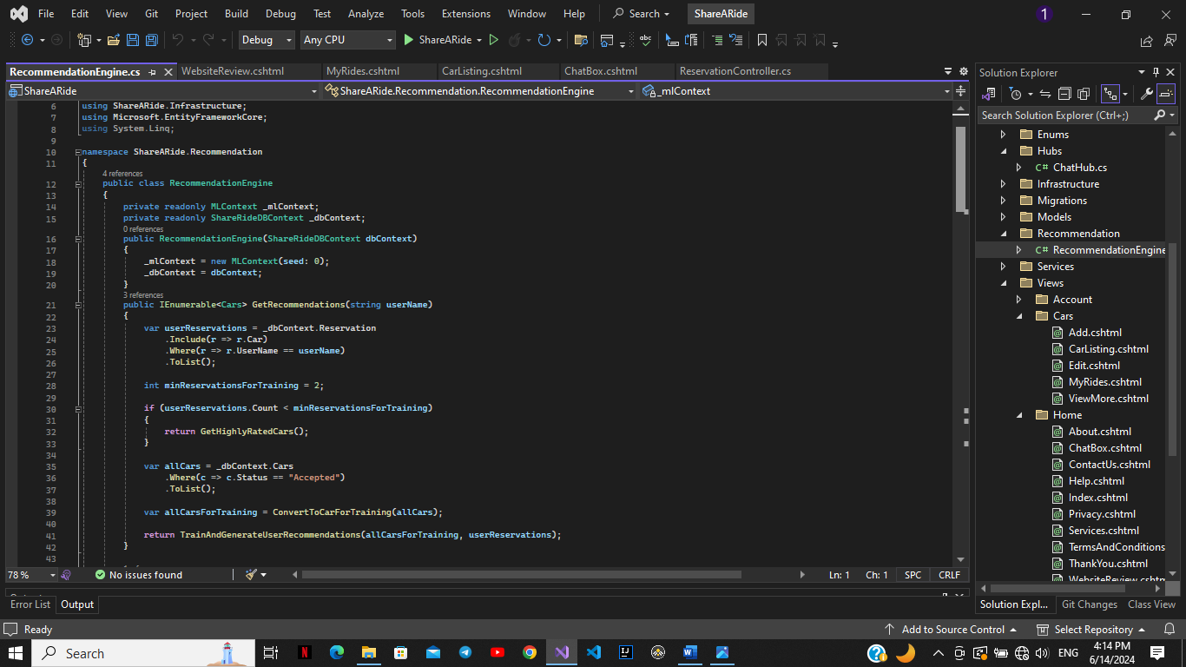

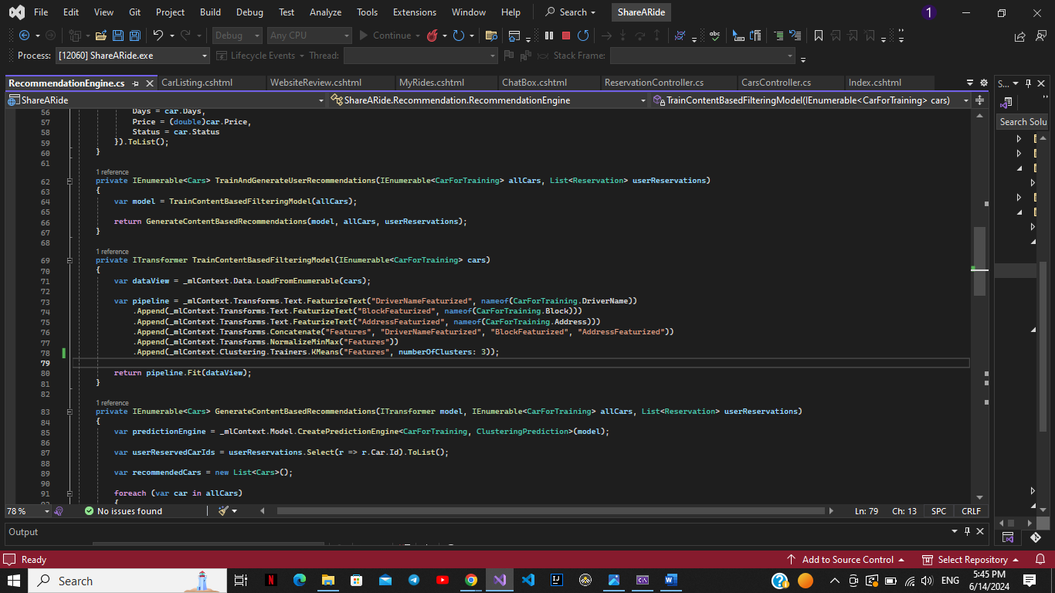

Figure 70 Part of Recommender System Code

The above figures show some piece of our recommendation system code. We used Machine Learning extension (Microsoft.ML). The type of recommendation we used is clustering. In get recommendation method, it checks the number of reservations each user had done if it is more than two it take the data of the reservations and train them in Train methods to give the recommendation based on driver name, block and address. If the number of reservations is less than two it then recommends the highly rated rides.

## **5.5 Conclusion:**

This part sums up for you our journey in implementing this software. It also clarifies for you the steps of having useful, friendly and successful website. We include all technologies, features and recommender system that we used with clear screen pictures and thorough page descriptions that help to properly display our website.

# **Chapter** **6: General Conclusion**

## **6.1 Recap:**

Ride sharing is the practice of sharing a ride journey with one or more people who are traveling to the same or a similar destination. Despite its benefits, ride sharing faces challenges such as coordinating schedules, safety concerns, lack of awareness, inconvenience, and inconsistent participation. To address these issues, our project, "Share a Ride," offers a dedicated ridesharing website for university students. This platform simplifies coordination with a matching algorithm that aligns schedules and routes, enhances safety with user verification and real-time tracking, and raises awareness through educational resources. By focusing on the needs of university students, "Share a Ride" aims to make ridesharing a practical, safe, and attractive option, reducing traffic and environmental impact on campus. In addition, it aims to solve the problem of the students who live far from the university in which it provides for them several ride options to be able to go and return from university in an easier way.

## **6.2 Reflections and Challenges:**

Every journey has its lessons and challenges. In our project, we had learned to be good team workers, to listen to each other’s opinions and work under pressure. Concerning the implementation part, we surely improved our skills in dot net and in AI field. For challenges, the most heartbreaking part was what is happening in south Lebanon now, which really affects our mental health and lack in progress since we lost people we love. Concerning implementation, the most challenging part was the AI since it was our first time that we include recommender system in a web application project. Despite what we have faced, we were able to accomplish this project with all our hard work and love.

## **6.3 Future work and potential improvements:**

Our project can be improved using several ways. First, it can be not considered only for our university we can make collaborations with several universities to let more students benefit from this website. In addition, for more security we can save all students ids and emails in our database to make sure that who enters the website are really university students. Second, we can add GPS for the rider to let the driver easily know his location to take him in the ride. Finally, the project could be improved by adding another AI feature including Traffic and Weather integration to inform users of the best times and routes helping them avoid congestion and to analyze weather conditions to notify users of potential delays.

**Alhamdulillah**

# **References:**

[1] Medium, <https://medium.com/@clara.sairafi/traffic-is-costing-lebanese-youth-their-mental-health-a852e21e3146>

[2] Tarraf Foundation, <https://tarraffoundation.org/blog-archive.html/article/2023/03/14/the-situation-of-the-lebanese-education-sector#:~:text=The%20education%20sector%20in%20Lebanon,and%20is%20overburdened%20and%20underfunded>

[3] Blablacar, <https://www.blablacar.co.uk/>

[4] Commutewithenterptise, <https://www.commutewithenterprise.com/en.html>

[5] Gopili, <https://www.gopili.co.uk/>

[6] LyftUp, <https://www.lyft.com/lyftup/programs>

[7] 123 Reg, <https://www.123-reg.co.uk/support/servers/what-is-mysql-and-why-do-i-need-it/#:~:text=MySQL%20is%20a%20relational%20database,purpose%20of%20a%20web%20database>.

[8] Actian, <https://www.actian.com/what-is-sql-server/#:~:text=Microsoft%20SQL%20Server%20is%20a,internet%20as%20a%20web%20service>.

[9] Oracle, <https://docs.oracle.com/>

[10] Back4App Blog, <https://blog.back4app.com/>

[11] SimForm, <https://www.simform.com/>